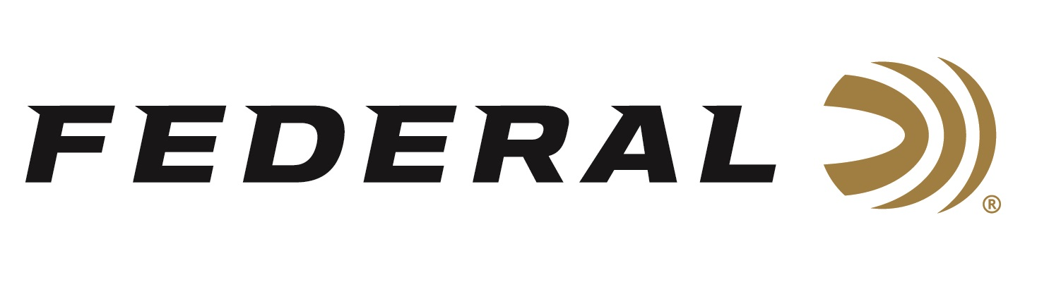

FOR IMMEDIATE RELEASE

Federal Ammunition Announces Its New “High Over All” Shotshell Product Line for Competitive Shooters

ANOKA, Minnesota – August 24, 2021 – Federal Ammunition is proud to announce its new Federal Premium High Over All (HOA) shotshell product line. HOA offers competitive shooters the best plastic shotshell product on the market. The product has been featured at regional and national events and will be showcased again at the Minnesota HOA State Championship Shoot held at Minnesota Horse and Hunt Club in Prior Lake, Minnesota, August 27-29.

“We are excited to build on the great momentum of this new product line. Competition shooters have been asking for a new competition load from Federal—and we’ve delivered with the best ever. ” said Jason Vanderbrink, Federal Ammunition’s President. “Top shoots across the country have been buzzing about our new HOA product and we look forward to rolling it out over the next months leading up to the National Sporting Clays Tournament in Texas.

Federal Premium High Over All leaves a trail of shattered targets in its wake and more reloads per shell. It’s hard, high-antimony lead payload and exclusive one-piece Podium wad produce the most consistent patterns, while the solid brass head and tapered, one-piece hull make reloading easier than ever. From beginners to elite and all shooters in-between, it’s the ultimate load for anyone wanting to knock more clay targets at the range. The complete list of sixteen 12-gauge, 2 3/4-inch offerings have a wide range of payloads, velocity, dram and shot sizes to accommodate the needs of any discipline of competitive shooting. A full line up of sub-gauge offerings is set to follow in 2022.

During the Minnesota HOA event, several Federal engineers, ambassadors and shooters will be on hand to showcase the product. Competition shooters on Team Federal which include Derrick Mein, Janet McDougal, Cameron Hicks, Curt Halbakken and Gregg Wolf will be there to compete in the championship.

For more information on all products from Federal or to shop online, visit
www.federalpremium.com.

Press Release Contact: JJ Reich
Senior Manager – Press Relations
E-mail: VistaPressroom@VistaOutdoor.com

About Federal Ammunition
Federal, headquartered in Anoka, MN, is a brand of Vista Outdoor Inc., an outdoor sports and recreation company. From humble beginnings nestled among the lakes and woods of Minnesota, Federal Ammunition has evolved into one of the world's largest producers of sporting ammunition. Beginning in 1922, founding president, Charles L. Horn, paved the way for our success. Today, Federal carries on Horn's vision for quality products and service with the next generation of outdoorsmen and women. We maintain our position as experts in the science of ammunition production. Every day we manufacture products to enhance our customers' shooting experience while partnering with the conservation organizations that protect and support our outdoor heritage. We offer thousands of options in our Federal Premium and Federal® lines-it's what makes us the most complete ammunition company in the business and provides our customers with a choice no matter their pursuit.

