10MM AUTO GOLDEN SABER BONDED & GOLDEN SABER DEFENSE
Joining Big Green’s handgun ammunition lineup is three new 10MM AUTO offerings. Including Remington’s top personal defensive round, Golden Saber Bonded and the new concealed carry go-to Golden Saber Defense in both full-size and compact options, personal defenders are now equipped for any situation. All proudly loaded in America by American workers, each 10MM ammunition is made from Remington’s reliable components.
FEATURES
- Three new 10MM AUTO load options
- 180 grain bullets, optimized for 10MM
- Ideal for personal protection, concealed carry, handgun hunting, or big game defense
- Available in Golden Saber Bonded, Golden Saber Defense and Golden Saber Defense Compact
- Loaded with trusted Remington-made primers, premier nickel-plated brass cases and Golden Saber projectiles
- 10MM also available in a 180gr. full metal jacket load, Remington/UMC SKU 23706

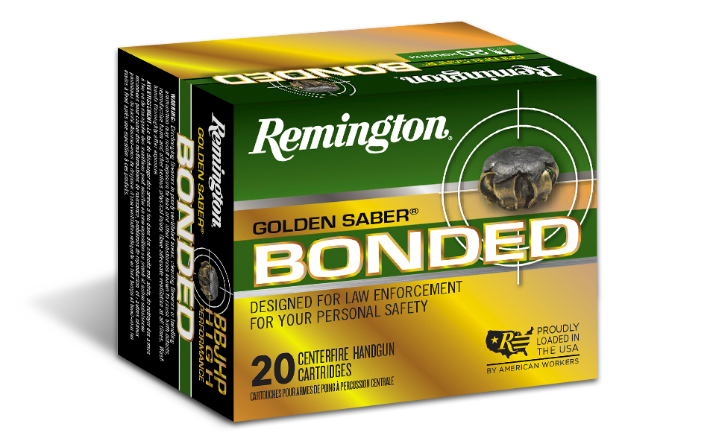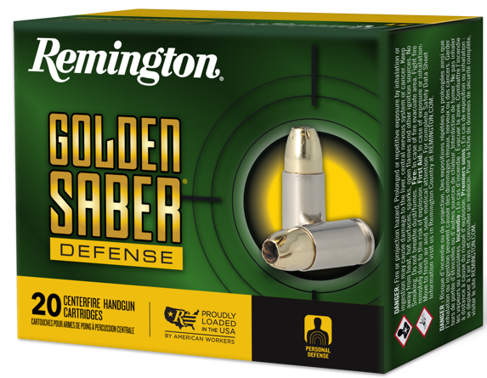

ORDER # | DESCRIPTION | MSRP
R21368 | Golden Saber Bonded 10mm 180gr Brass Jacketed Hollow Point Bonded | $47.99
R21369 | Golden Saber Defense 10mm 180gr Brass Jacketed Hollow Point | $38.99
R21370 | Golden Saber Defense Compact 10mm 180gr Brass Jacketed Hollow Point | $38.99

