22 TARGET
Competitors know, consistent on-target performance is a must. For the highest levels of rimfire reliability, trust Remington 22 Target. 40-grain round nose lead bullets are propelled by a carefully chosen combination of primer and propellant charges of exacting consistency. Delivering match-grade accuracy and performance from loading to trigger pull and impact, 22 Target is Remington’s Premier rimfire offering for championship performance.
FEATURES
- Match-grade ammunition
- Loaded with top-quality Premier components
- Remington’s most premium 22LR load, specifically built to meet the demands of competition
- Proudly loaded in America by American workers
- Multiple packaging choices, including 50 or 100-round count options
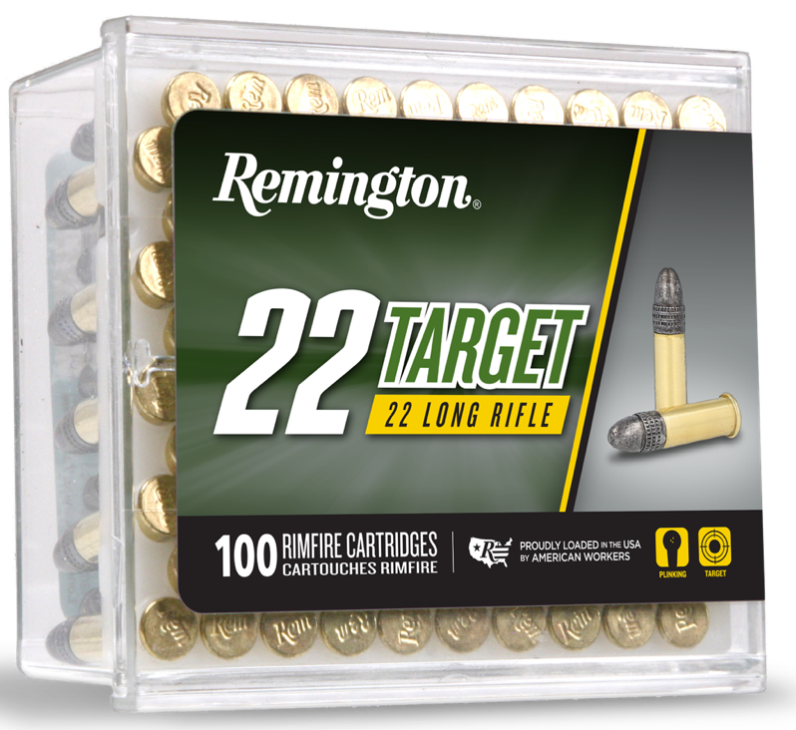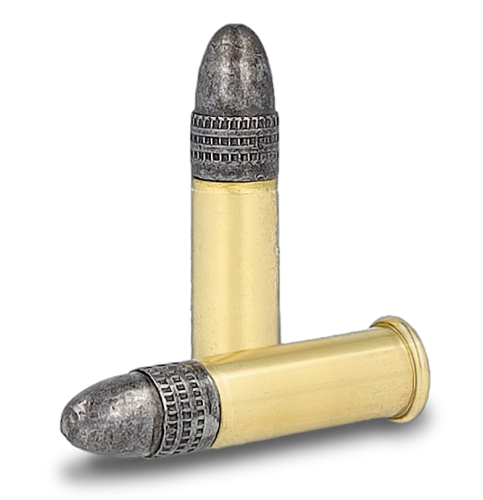
ORDER # | DESCRIPTION | UPC | MSRP
21022 | 22 TARGET 22LR LEAD ROUND NOSE 40GRAIN 50 PACK | 0-47700-00110-4 | $7.99
21284 | 22 TARGET 22LR LEAD ROUND NOSE 40GRAIN 100 PACK | 0-47700-00120-3 | $15.99

