22 VIPER®

Plated truncated cone bullets pack plenty of bite for small game of all types and fast-paced .22 excitement of every sort. These hyper-velocity loads are ideal for small-game and hold their own at the target board as well. For fast-striking, 22 performance, Viper® can't be beat.
FEATURES

- Perfect for small game and target shooting
- Features plated truncated cones

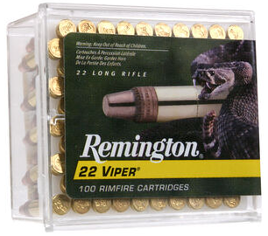

ORDER # | DESCRIPTION | UPC | MSRP
21080 | 22 LR 36GR – 50 CT | 0-47700-00060-2 | $6.99
21239 | NEW 22 LR 36GR – 225 CT | 0-47700-48350-4 | $30.99
21288 | 22 LR 36GR – 100 CT | 0-47700-48120-3 | $13.99

