22 YELLOW JACKET®

Plated hollow point bullets leave a hyper-velocity sting wherever they're dispatched. Bullets are specially designed to deliver maximum on-game energy with excellent precision. Send a few downrange today and see for yourself.
FEATURES

- Designed with precision in mind
- Plated truncated cone hollow point
- Ideal for small game

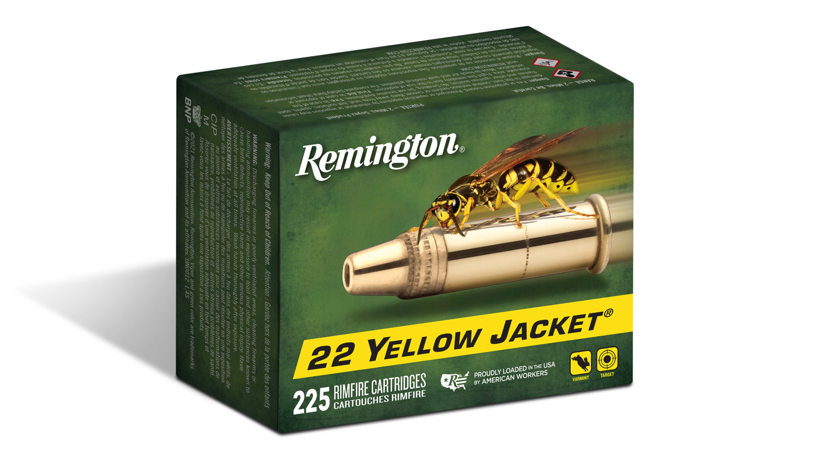

ORDER # | DESCRIPTION | UPC | MSRP
21280 | 22LR 33GR – 100 CT | 0-47700-48110-4 | $13.99
21074 | 22 LR 33GR – 50 CT | 0-47700-00090-9 | $6.99
21233 | 22LR 33GR – 225 CT | 0-47700-48340-5 | $31.99

