C-BEE 22®

Remington CBee 22® combines low noise with excellent shot-to-shot consistency. It's 33-grain truncated hollow point bullet is ideal for dispatching small game as quietly as possible. It's tiny report makes it an excellent choice for new shooters as well.
FEATURES

- Ideal for small game as well as new shooters
- Features a plated truncated cone

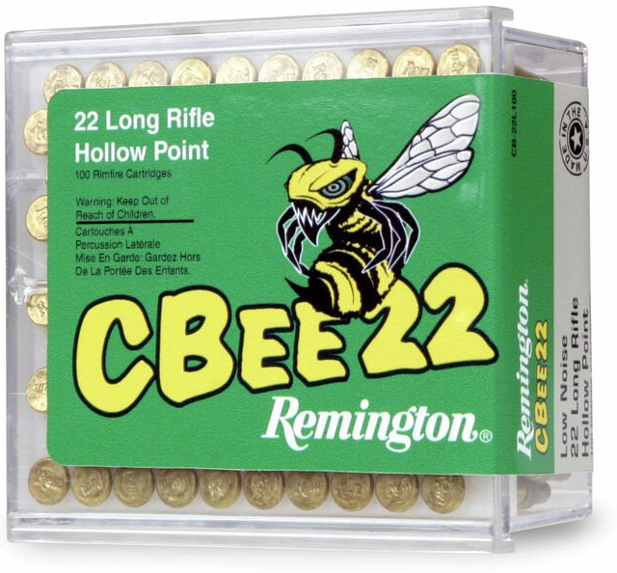

ORDER # | DESCRIPTION | UPC | MSRP
21119 | 22 LR 33GR | 0-47700-48225-2 | $16.99

