CORE-LOKT® TIPPED
The Deadliest Mushroom in the Woods is Now Even Deadlier with the introduction of Remington's groundbreaking new centerfire rifle big game line of ammunition, Core-Lokt Tipped. New Core-Lokt Tipped offers the same proven on-game performance as original Core-Lokt with improved accuracy and long-range potential. Core-Lokt Tipped combines truer flight, flatter trajectory, and devastating terminal energy. This is the next evolution of big game ammunition.
FEATURES
- BIG GREEN POLYMER TIP – Improves long-range ballistics, in-flight accuracy, and initiates rapid expansion
- PROVEN CORE-LOKT JACKET – Tuned for optimal performance on big game
- MATCH-GRADE ACCURACY – Center of gravity adjusted rearward to maximize accuracy
- POLISHED BRASS – Factory-fresh Remington brass of the highest quality
- POWDER – Premier propellant blend specially chosen for optimal performance
- PRIMER – Dependable Remington primer for fast and sure ignition

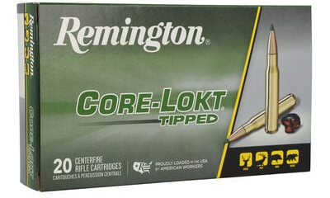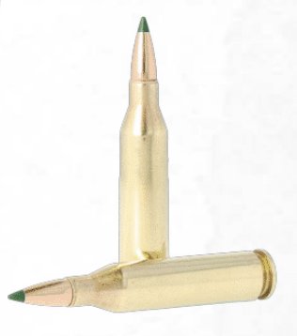
ORDER # | DESCRIPTION | UPC | MSRP
29015 | 243 WIN, 95 GRAIN | 0-47700-40980-1 | $46.99
29017 | 6.5 CREEDMOOR, 129 GRAIN | 0-47700-41090-6 | $50.99
29019 | 270 WIN, 130 GRAIN | 0-47700-41230-6 | $50.99
29020 | 280 REMINGTON, 140 GRAIN | 0-47700-41370-9 | $58.99
29021 | 7MM REMINGTON MAGNUM, 150 GRAIN | 0-47700-41510-9 | $60.99
29027 | 30-06 SPRG, 150 GRAIN | 0-47700-41530-7 | $51.99
29035 | 30-06 SPRG, 165 GRAIN | 0-47700-41770-7 | $51.99
29037 | 30-06 SPRG, 180 GRAIN | 0-47700-41780-6 | $51.99
29039 | 308 WIN, 150 GRAIN | 0-47700-41800-1 | $50.99
29044 | 308 Win, 165 grain | 0-47700-48500-3 | $50.99
29041 | 308 Win, 180 grain | 0-47700-48510-2 | $50.99
R29038 | 308 Win Magnum, 180 grain | 0-47700-41790-5 | $64.99
29043 | 300 WSM, 150 grain | 0-47700-48520-1 | $68.99

