CORE-LOKT
Since 1939, Core-Lokt has been a whitetail’s worst enemy. The original controlled expansion bullet, it’s filled more tags on more continents than any other load. Available in more caliber and cartridge options than any other deer load, Core-Lokt’s tapered copper jacket is locked to a solid lead core to deliver massive 2X expansion, weight retention and consistent on-game results. Core-Lokt. The buck stops here.
FEATURES
- Consistent 2X expansion for large terminal wound
- Deep penetration and high weight retention
- Proven lethal, the original controlled-expansion bullet
- Available in more caliber and cartridge options than any other deer load
- Pointed Soft Point, Soft Point, Hollow Point or Ultra Bonded options
- COMING SOON 450 Bushmaster and 350 Legend
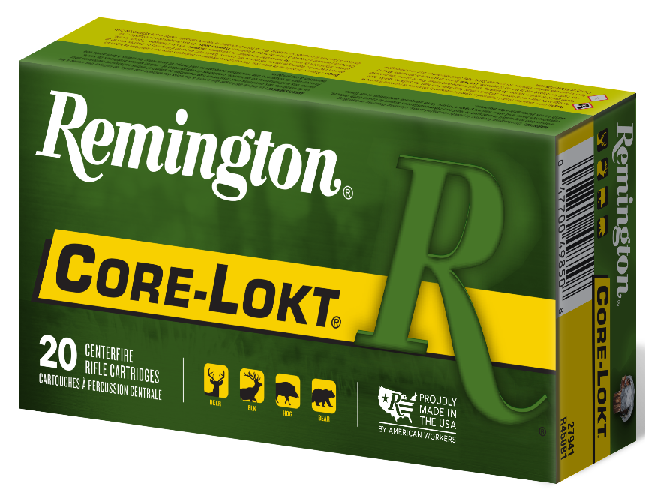

ORDER # | DESCRIPTION | UPC | MSRP
22111 | 223 REM 62GR CORE-LOKT® ULTRA BONDED PSP | 0-47700-49050-2 | $43.99
29049 | 6MM CREEDMOOR 100GR CORE-LOKT PSP | 0-47700-47930-9 | $39.99
29051 | 6MM REM 100GR CORE-LOKT PSP | 0-47700-05160-4 | $61.99
R27802 | 243 WIN 100GR CORE-LOKT PSP | 0-47700-05190-1 | $35.99
21507 | 25-06 REM 100GR CORE-LOKT PSP | 0-47700-05210-6 | $47.99
21515 | 25-06 REM 120GR CORE-LOKT PSP | 0-47700-05220-5 | $47.99
28364 | 25-20 WIN 86GR CORE-LOKT PSP | 0-47700-05230-4 | $124.99
29077 | 250 SAV 100GR CORE-LOKT PSP | 0-47700-05240-3 | $69.99
29140 | 6.5 X 55 SWEDISH 140GR CORE-LOKT PSP | 0-47700-06510-3 | $66.99
27657 | 6.5 CREEDMOOR 140GR CORE-LOKT PSP | 0-47700-47880-7 | $38.99
21292 | 260 REM 140GR CORE-LOKT PSP | 0-47700-17260-6 | $68.99
29493 | 264 WIN MAG 140GR CORE-LOKT PSP | 047700-05270-0 | $100.99
21325 | 270 WIN 100GR CORE-LOKT PSP | 0-47700-05280-9 | $35.99
27808 | 270 WIN 130GR CORE-LOKT PSP | 0-47700-05290-8 | $35.99
28940 | 270 WSM 130GR CORE-LOKT PSP | 0-47700-35990-8 | $75.99
28313 | 280 REM140GR CORE-LOKT PSP | 0-47700-06600-4 | $57.99
29069 | 280 REM 150GR CORE-LOKT PSP | 0-47700-05320-2 | $57.99
21337 | 7MM-08 REM 140GR CORE-LOKT PSP | 0-47700-05340-0 | $46.99
28821 | 7MM REM MAGNUM 140GR CORE-LOKT PSP | 0-47700-06610-3 | $52.99
29487 | 7MM REM MAGNUM 150GR CORE-LOKT PSP | 0-47700-05350-9 | $52.99
27814 | 7MM REM MAGNUM 175GR CORE-LOKT PSP | 0-47700-05360-8 | $52.99
29031 | 7MM MAUSER (7X57) 140GR CORE-LOKT PSP | 0-47700-05370-7 | $66.99
27759 | 7MM REM ULTRA MAG 150GR CORE-LOKT PSP | 0-47700-47960-6 | $90.99
27874 | 7MM REM SHORT ACTION ULTRA MAG 150GR CORE-LOKT PSP | 0-47700-35780-5 | $83.99
29130 | 7 X 64 BRENNEKE 140GR CORE-LOKT PSP | 0-47700-16520-2 | $49.99
28345 | 30-40 KRAG 180GR CORE-LOKT PSP | 0-47700-05440-7 | $74.99
21401 | 30-06 SPRG 125GR CORE-LOKT PSP | 0-47700-05450-6 | $44.99
27826 | 30-06 SPRG 150GR CORE-LOKT PSP | 0-47700-05460-5 | $35.99
R21415 | 30-06 SPRG 165GR CORE-LOKT PSP | 0-47700-05520-6 | $35.99
27828 | 30-06 SPRG 180GR CORE-LOKT PSP | 0-47700-05490-2 | $35.99
21465 | 300 SAV 150GR CORE-LOKT PSP | 0-47700-05540-4 | $72.99
29495 | 300 WIN MAG 150GR CORE-LOKT PSP | 0-47700-05570-1 | $50.99
29497 | 300 WIN MAG 180GR CORE-LOKT PSP | 0-47700-05580-0 | $50.99
27941 | 450 BUSHMASTER 300GR CORE-LOKT PSP | 0-47700-49850-8 | $66.99
29489 | 300 WSM 150GR CORE-LOKT PSP | 0-47700-38530-3 | $66.99
27842 | 308 WIN 150GR CORE-LOKT PSP | 0-47700-05600-5 | $35.99
21479 | 308 WIN 180GR CORE-LOKT PSP | 0-47700-05620-3 | $35.99
29279 | 300 WBY MAG 180GR CORE-LOKT PSP | 0-47700-07030-8 | $137.99
29125 | 7.62 X 39 125GR CORE-LOKT PSP | 0-47700-07050-6 | $55.99
27954 | 300 REM SHORT ACTION ULTRA MAG 165GR CORE-LOKT PSP | 0-47700-35800-0 | $86.99
27641 | 300 REM ULTRA MAG 180GR CORE-LOKT PSP | 0-47700-47950-7 | $90.99
29485 | 30 REM AR 150GR CORE-LOKT PSP | 0-47700-40500-1 | $44.99
27942 | 338 REM ULTRA MAG 250GR CORE-LOKT PSP | 0-47700-35220-6 | $99.99
22189 | 338 WIN MAG 225GR CORE-LOKT PSP | 0-47700-06650-9 | $115.99
22191 | 338 WIN MAG 250GR CORE-LOKT PSP | 0-47700-06660-8 | $115.99
21495 | 35 WHELEN 200GR CORE-LOKT PSP | 0-47700-06960-9 | $92.99
28335 | 257 ROBERS 117GR CORE-LOKT PSP | 0-47700-05250-2 | $70.99
27810 | 270 WIN 150GR CORE-LOKT SP | 0-47700-05310-3 | $35.99
28417 | 280 REM 165GR CORE-LOKT SP | 0-47700-05330-1 | $57.99
28322 | 30 CARBINE 110GR CORE-LOKT SP | 0-47700-05380-6 | $113.99
27818 | 30-30 WIN 150GR CORE-LOKT SP | 0-47700-05400-1 | $32.99
27820 | 30-30 WIN 170GR CORE-LOKT SP | 0-47700-05410-0 | $32.99
27644 | 30-30 WIN 125GR CORE-LOKT SP | 0-47700-38490-0 | $32.99
21407 | 30-06 SPRG 180GR CORE-LOKT SP | 0-47700-05480-3 | $35.99
R27830 | 30-06 SPRG 220GR CORE-LOKT SP | 0-47700-05510-7 | $51.99
27848 | 308 MARLIN EXPRESS 150GR CORE-LOKT SP | 0-47700-40140-9 | $55.99
27844 | 308 WIN 180GR CORE-LOKT SP | 0-47700-05610-4 | $35.99
21471 | 303 BRITISH 180GR CORE-LOKT SP | 0-47700-05590-9 | $71.99
21489 | 32 WIIN SPL 170GR CORE-LOKT SP | 0-47700-05690-6 | $62.99
27852 | 35 REM 200GR CORE-LOKT SP | 0-47700-05710-1 | $61.99
29475 | 444 MARLIN 240GR CORE-LOKT SP | 0-47700-05750-7 | $83.99
21459 | 45-70 GOVT (FULL PRESSURE) 405GR CORE-LOKT SP | 0-47700-47540-0 | $66.99
29473 | 45-70 GOVT (REDUCED PRESSURE) 405GR CORE-LOKT SP | 0-47700-05780-4 | $66.99
21395 | 30-30 WIN 170GR CORE-LOKT HP | 0-47700-05420-9 | $32.99

