22 GOLDEN BULLET
Legendary 22 Golden Bullet Plated round nose and hollow point bullets are engineered for easy cycling and solid performance. Golden Bullet’s blistering high velocity increases downrange energy and extends your effective range. Remington’s Improved priming compound ensures consistent ignition at a great value. Available in multiple packaging sizes for range day as well as loads suited for plinking or small game.
FEATURES
- 22 Short or 22 Long Rifle
- High velocity for flat shooting accuracy as well as terminal performance on small game
- 22 Short utilizes a 29-grain plated round nose bullet
- 22 LR: 40-gr. plated round nose great for target practice or plinking, 36-gr. plated hollow point for small game
- Available in 50, 100, 225, or 525 packs, as well as the famous 1,400 round Bucket O’ Bullets
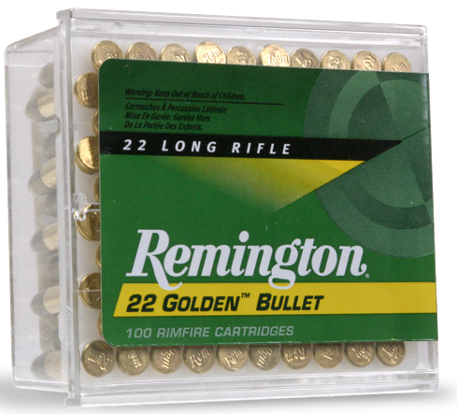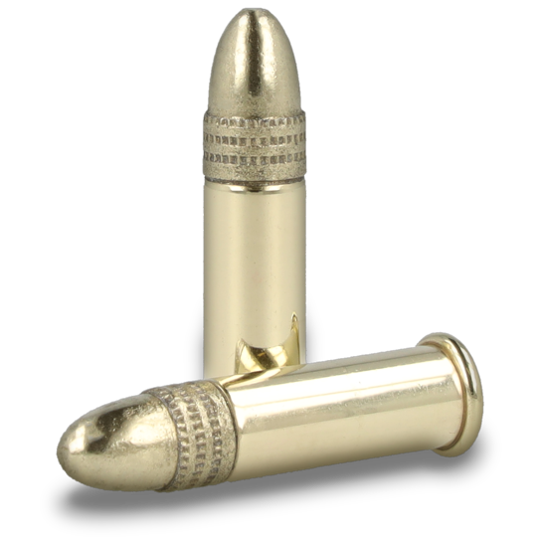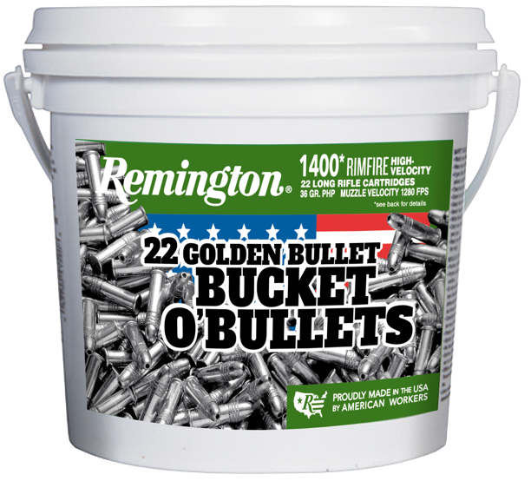

ORDER # | DESCRIPTION | UPC | MSRP
21000 | 22 GOLDEN BULLET, 22 SHORT, HV 29GR RN | 0-47700-00010-7 | $6.99
21001 | 22 GOLDEN BULLET, 22 SHORT, HV 29GR RN | 0-47700-48140-1 | $14.99
21008 | 22 GOLDEN BULLET, 22 LR, HV 36GR HP | 0-47700-00070-1 | $5.99
21278 | 22 GOLDEN BULLET, 22 LR, HV 36GR HP | 0-47700-00080-0 | $12.99
21229 | 22 GOLDEN BULLET, 22 LR, HV 36GR HP | 0-47700-48260-6 | $22.99
21250 | 22 GOLDEN BULLET, 22 LR, HV 36GR HP | 0-47700-00910-0 | $49.99
21231 | 22 GOLDEN BULLET, 22 LR, HV 36GR HP | 0-47700-41520-8 | $135.99
R21006 | 22 GOLDEN BULLET, 22 LR, HV 40GR RN | 0-47700-00040-4 | $5.99
21276 | 22 GOLDEN BULLET, 22 LR, HV 40GR RN | 0-47700-00050-3 | $11.99

