GOLDEN SABER BONDED
Golden Saber® – A name trusted for decades in the law enforcement community is available to you as a defensive round for when it matters most. Revolutionary barrier-penetration capacity combined with Remington’s special bonded-bullet design ensures optimal performance and expansion when stopping a threat. Made-grade accuracy at common defensive ranges and carefully loaded to exacting standards, Golden Saber Bonded is Remington’s highest quality defensive handgun round. Newly available in 10MM Auto in 2022.
FEATURES
- Trusted as the carry-round for top law enforcement agencies nationwide
- Lead core hot-bonded to brass jacket – An exclusive Remington process
- Jacket stiffness and wall thickness optimized to eliminate over-expansion
- Exceptional weight retention up to 97%, even though barriers like auto glass
- Reduced bullet nose diameter for precise bore alignment, producing top-tier accuracy
- Premier-quality reliable primers, low-flash propellants, and nickel-plated cases for smooth feeding & extraction
- Available in 357 SIG, 9MM Luger, 40 S&W, 45 AUTO and NEW 10MM AUTO
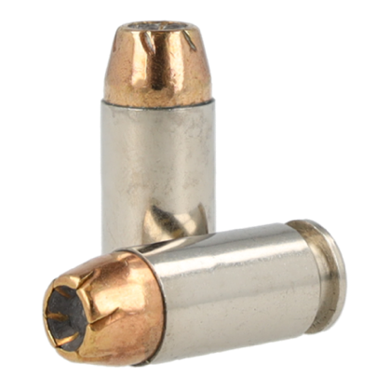
ORDER # | DESCRIPTION | UPC | MSRP
29341 | 9MM LUGER +P 124GR BJHP BONDED | 0-47700-49450-0 | $40.99
29343 | 9MM LUGER 147GR BJHP BONDED | 0-47700-49460-9 | $40.99
29407 | 357 SIG 125GR BJHP BONDED | 0-47700-49470-8 | $42.99
29363 | 40 S&W 165GR BJHP BONDED | 0-47700-49480-7 | $42.99
29365 | 40 S&W 180GR BJHP BONDED | 0-47700-49490-6 | $45.99
29325 | 45 AUTO 185GR BJHP BONDED | 0-47700-49500-2 | $43.99
29327 | 45 AUTO 230GR BJHP BONDED | 0-47700-49510-1 | $43.99
R21368 | NEW 10MM 180GR BJHPB BONDED | 0-47700-66040-0 | $47.99

