GOLDEN SABER DEFENSE COMPACT
Based on the same platform trusted by law enforcement professionals, now available for personal defense. Optimized for full size handguns as well as compacts and micro-compacts and loaded with our high-performance Golden Saber Brass Jacketed Hollow Point (BJHP), these rounds deliver massive expansion and deep penetration for ultimate stopping power.
FEATURES
- Carefully tuned loads for compact handguns and shorter barrel lengths.
- Quality Components: Precision jacket with nose cuts to control expansion and optimize energy transfer, waterproofed case mouth and primer, and nickel-plated cases for ultimate reliability
- Available in popular calibers and grain weight options, including two

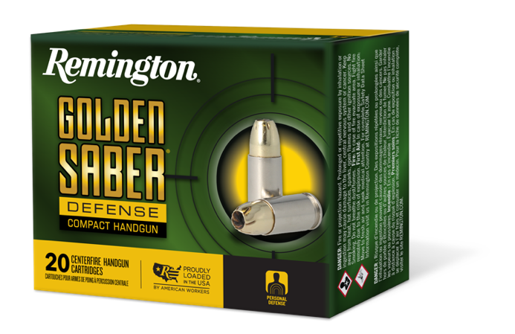

ORDER # | DESCRIPTION | UPC | MSRP
27613 | NEW Compact 9MM LUGER 124GR BJHP | 0-47700-48950 6 | $35.99
27615 | NEW Compact 380 AUTO 102GR BJHP | 0-47700-48960 5 | $35.99
27617 | NEW Compact 38 SPL +P 125GR BJHP | 0-47700-48890 5 | $35.99
27618 | NEW Compact 40 S&W 180GR BJHP | 0-47700-48980 3 | $35.99
27619 | NEW Compact 45 AUTO 230GR BJHP | 0-47700-48990-2 | $37.99

