GOLDEN SABER DEFENSE
Based on the same platform trusted by law enforcement professionals, now available for personal defense. Optimized for full size handguns as well as compacts and micro-compacts and loaded with our high-performance Golden Saber Brass Jacketed Hollow Point (BJHP), these rounds deliver massive expansion and deep penetration for ultimate stopping power.
FEATURES
- Golden Saber Defense: Optimized for full-size handguns.
- Quality Components: Precision jacket with nose cuts to control expansion and optimize energy transfer, waterproofed case mouth and primer, and nickel-plated cases for ultimate reliability
- Available in popular calibers and grain weight options, including two NEW 10MM AUTO loads
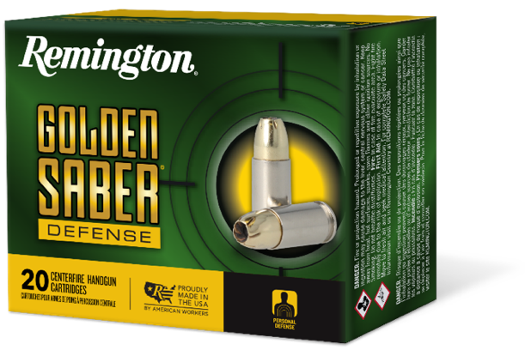
ORDER # | DESCRIPTION | UPC | MSRP
27600 | NEW 357 MAG 125GR BJHP | 0-47700-48840-0 | $37.99
27601 | NEW 9MM LUGER 124GR BJHP | 0-47700-48850-9 | $35.99
27603 | NEW 9MM LUGER +P 124GR BJHP | 0-4770048860-8 | $35.99
27604 | NEW 9MM LUGER 147GR BJHP | 0-4770048870-7 | $35.99
27605 | NEW 380 AUTO 102GR BJHP | 0-4770048880-6 | $35.99
27606 | NEW 38 SPL +P 125GR BJHP | 0-4770048890-5 | $35.99
27607 | NEW 40 S&W 165GR BJHP | 0-4770048900-1 | $35.99
27608 | NEW 40 S&W 180GR BJHP | 0-4770048910-0 | $35.99
27609 | NEW 45 AUTO 185GR BJHP | 0-4770048920-9 | $37.99
27611 | NEW 45 AUTO +P 185GR BJHP | 0-4770048930-8 | $37.99
27612 | NEW 45 AUTO 230GR BJHP | 0-4770048940-7 | $37.99
21369 | NEW 10MM 180GR BJHP | 0-4770066040-0 | $38.99

