GUN CLUB CURE
The newest addition to Remington’s Gun Club® product family is destined to help real families nationwide. A portion of the proceeds from the sale of this ammunition benefits children’s hospitals and disease research, meaning your day at the trap, skeet or sporting course shooting gives back to those in need. Gun Club Cure’s unique hull shows your support for a great cause. Proudly loaded in America with Remington components you know and trust, be a champion for children with Gun Club Cure. Available summer 2022 in two 12GA loads, including a low-recoil version.
FEATURES
- Proceeds from the sale of this ammo benefits children’s hospitals and disease research
- Top-quality Unibody Hull, in a unique new hull color, Remington Blue
- Made with trusted Remington components, including Gun Club Shot, carefully chosen primer/propellants, the Remington Power Piston® Wad and premier hull construction
- Available in two 12GA loads, including low recoil
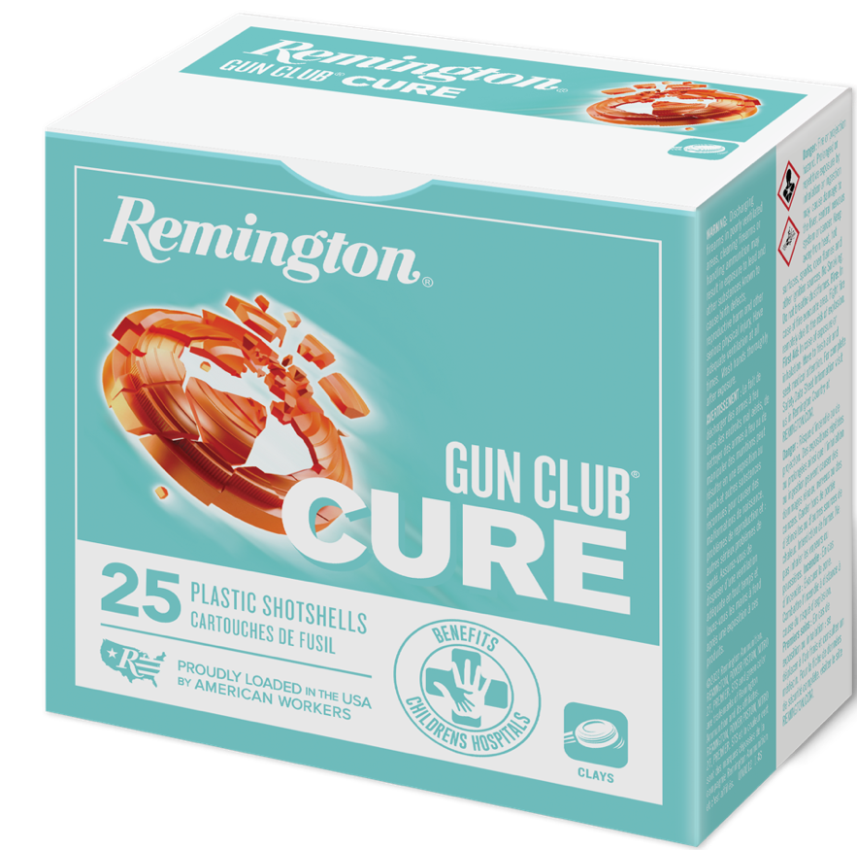
ORDER # | DESCRIPTION | UPC | MSRP
R20031 | 12GA 2-3/4IN 2.5 DRAM 1-1/8OZ 8 Shot 1100 FPS Managed Recoil | 0 47700 53220 2 | $11.99
R20029 | 12GA 2-3/4IN 2.75 DRAM 1-1/8OZ 8 Shot 1145 FPS | 0 47700 53210 3 | $11.99

