HEAVY DOVE LOAD

Remington Heavy Dove Loads. Long considered to be some of the best-balanced, most consistent patterning upland field loads available. They're the hunter's choice for fast-flying doves and a wide variety of game-bird applications.
FEATURES

- Available in 12 and 20 gauge with shot size options of 7½ and 8
- Balanced and consistent patterning
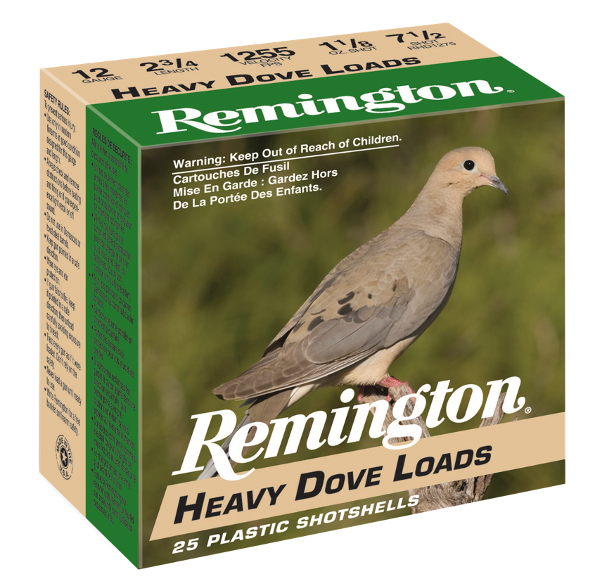

ORDER # | DESCRIPTION | UPC | MSRP
28755 | 12GA 2-3/4IN 1-1/8OZ 7.5 | 0-47700-50870-2 | $14.99
28777 | 12GA 2-3/4IN 1OZ 7.5 | 0-47700-50900-6 | $13.99
28757 | 12GA 2-3/4IN 1-1/8OZ 8 | 0-47700-50880-1 | $14.99
28779 | 12GA 2-3/4IN 1OZ 8 | 0-47700-50910-5 | $13.99

