MANAGED RECOIL RIFLE
HALF THE RECOIL. TWICE THE CONFIDENCE.
For years, shooters have wished for and hand loaders have attempted to create a low-recoil load – usually by simply reducing the amount of gunpowder. The results did create low kick, but at the expense of bullet expansion and on-game performance. For many years, the gap between low recoil and effective hunting performance seemed an insurmountable one. That is, until now. Managed-Recoil® Centerfire Ammunition delivers trusted Remington® field-proven hunting performance out to 200 yards, with half the recoil. How? Through a specialized new bullet developed specifically to perform at lower velocity levels. Managed-Recoil® bullets deliver 2x expansion with over 75% weight retention on shots inside of 50 yards and out to 200 yards. The result is a high-performance bullet optimized to provide the on-game results you've come to expect from Remington Ammunition with just half the felt recoil.
FEATURES
- Half the recoil
- Field-proven hunting performance out to 200 yards
- 2x bullet expansion
- 75% weight retention on shots inside of 50 yards and out to 200 yards
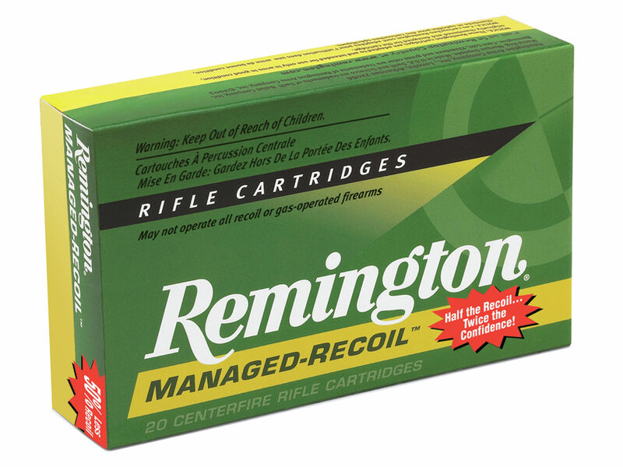
ORDER # | DESCRIPTION | UPC | MSRP
27644 | 30-30 WIN 125GR CORE-LOKT SP | 0-47700-38490-0 | $30.99

