PREMIER® NITRO 27®
Designed specifically for back-fence trap and long-range sporting clays, Premier Nitro 27 Target Loads deliver consistent handicap velocity and pattern uniformity shot after shot. Our Premier body and Power Piston® Wad reduces felt recoil while retaining high velocity and world-class performance, allowing avid trap shooters to stay fresh for the shoot-off. What’s more, Premier Nitro 27 scores just as high on fast-moving doves and boasts long-range effectiveness that’s backed by a long list of Remington trapshooting champions.
FEATURES
- Premier Nitro 27 Handicap loads are specifically designed for long-yardage trapshooting and sporting clays
- High-Antimony Lead Shot. Superior quality and roundness magnum shot for denser patterns at longer ranges
- Premier Body. Unibody construction delivers superior, world-class hull performance
- Custom Propellant Blend. Superior consistency and velocity
- Premier STS® Primer #209 primer optimally matched with propellant for perfect ignition
- Remington Power Piston® Wad. Engineered for consistent velocity, produces high Handicap scores
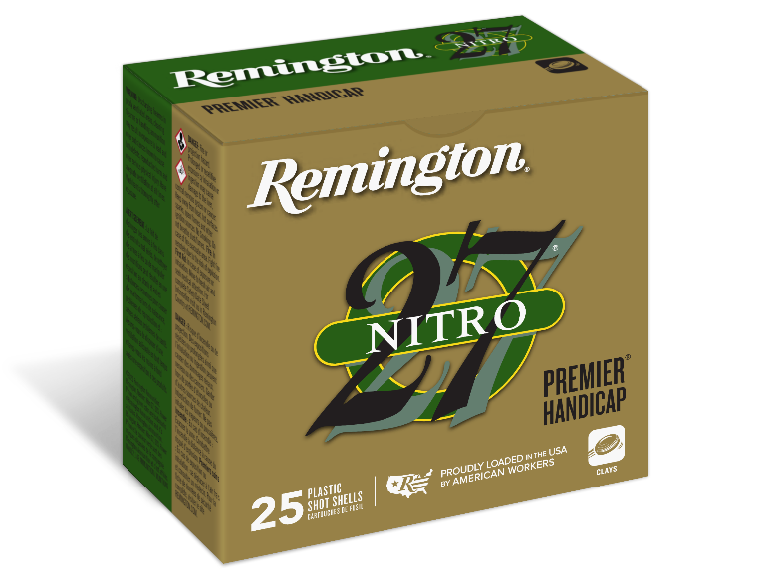
ORDER # | DESCRIPTION | UPC | MSRP
20227 | 12GA 2-3/4IN HDCP 1OZ 7-1/2 | 0-4770031390-0 | $16.99
20222 | 12GA 2-3/4IN HDCP 1-1/8OZ 7.5 | 0-4770030640-7 | $16.99
20224 | 12GA 2-3/4IN HDCP 1-1/8OZ 8 | 0-4770030650-6 | $16.99
28867 | 12GA 2-3/4IN HDCP 1-1/8OZ 7.5 (100 RND PACK) | 0-4770052780-2 | $67.99
28869 | 12GA 2-3/4IN HDCP 1-1/8OZ 8 (100 RND PACK) | 0-4770052790-1 | $67.99

