NITRO MAGNUM

The original game-changing buffered magnum shotshells from Remington. The shot charge is packed with a generous amount of shock-absorbing polymer buffering and surrounded by our patented Power Piston® wad. Remington's specially hardened shot is protected all the way down the barrel delivering dense, even patterns and uniform shot strings.
FEATURES

- Featuring our patented Power Piston® wad
- Distributes even, dense patterns shot after shot
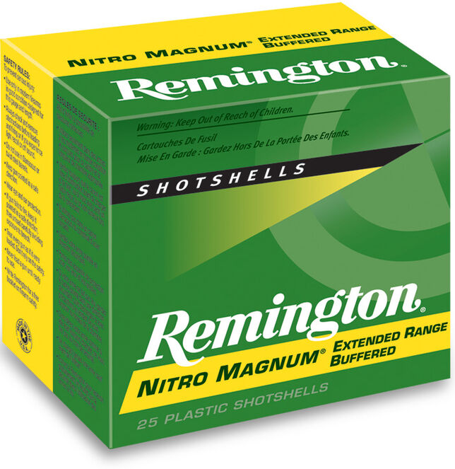

ORDER # | DESCRIPTION | UPC | MSRP
26674 | 12GA 3IN 1-5/8OZ 4 | 0-47700-01320-6 | $39.99
26676 | 12GA 2-3/4IN 1-1/2OZ 2 | 0-47700-01270-4 | $37.99
20666 | 20GA 2-3/4IN 1-1/8OZ 6 | 0-47700-01380-0 | $34.99
26685 | 12GA 3IN 1-7/8OZ 6 | 0-47700-03950-3 | $43.99
20664 | 20GA 2-3/4IN 1-1/8OZ 4 | 0-47700-01370-1 | $34.99
26684 | 12GA 3IN 1-7/8OZ 4 | 0-47700-01360-2 | $43.99
20376 | 12GA 2-3/4IN 1-5/8OZ 6 | 0-47700-01330-5 | $39.99
20672 | 20GA 3IN 1-1/4OZ 4 | 0-47700-01410-4 | $34.99
26682 | 12GA 3IN 1-7/8OZ 2 | 0-47700-01350-3 | $43.99
20674 | 20GA 3IN 1-1/4OZ 6 | 0-47700-01420-3 | $34.99
26678 | 12GA 2-3/4IN 1-1/2OZ 4 | 0-47700-01280-3 | $37.99

