NITRO PHEASANT
Rooster! To bring down tough upland birds with confidence, you need the best pheasant ammunition on the market. Made with copper-plated magnum-grade high antimony lead, Nitro Pheasant’s Copper-Lokt Shot produces dense, dependable patterns and retains lethal energy downfield to take down the biggest birds with ease. Available in high-velocity and magnum loads in both 12- and 20-gauges, Nitro Pheasant® is Remington’s best shell for upland game at any range. Your bird dog will thank you.
FEATURES
- Copper-Lokt Shot – Magnum grade, the hardest lead Remington makes for hunting
- Copper-Lokt Shot stays round for true flight, tight patterns and greater penetration
- Patented Power Piston Wad® – Protects and cushions shot for dependable patterns over a wide range of field hunting conditions
- Premier-tier components – High-brass head, unibody hull, and a special blend of propellants for high performance patterns and velocity
- Available in high velocity and magnum loads in 12 and 20 gauge
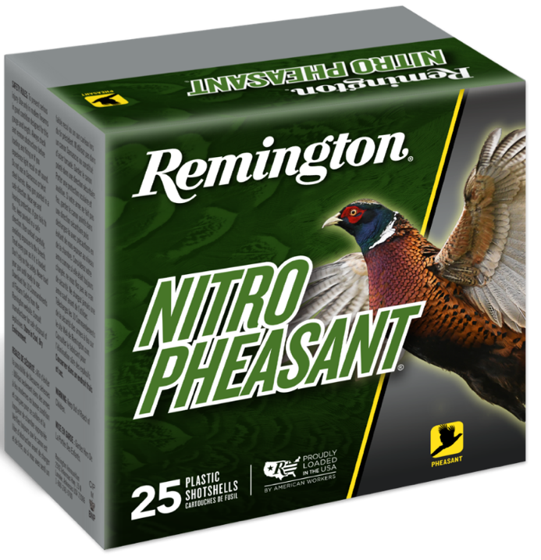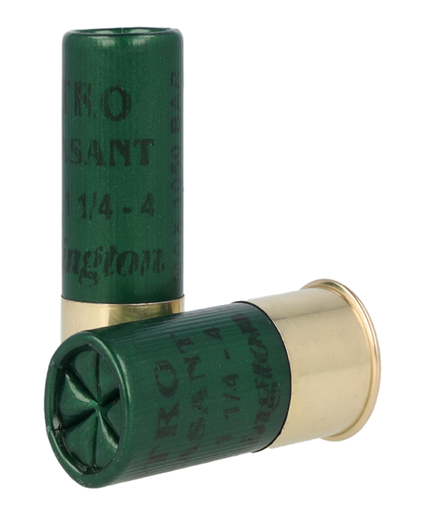
ORDER # | DESCRIPTION | UPC | MSRP
28620 | 12GA 2-3/4IN 1-1/4OZ 4 | 0-47700-34730-1 | $34.99
28622 | 12GA 2-3/4IN 1-1/4OZ 5 | 0-47700-34740-0 | $34.99
28624 | 12GA 2-3/4IN 1-1/4OZ 6 | 0-47700-34750-9 | $34.99
28632 | 12GA 2-3/4IN 1-3/8OZ 4 | 0-47700-34700-4 | $35.99
28634 | 12GA 2-3/4IN 1-3/8OZ 5 | 0-47700-34710-3 | $35.99
28636 | 12GA 2-3/4IN 1-3/8OZ 6 | 0-47700-34720-2 | $35.99
28646 | 20GA 2-3/4IN 1OZ 5 | 0-47700-34670-0 | $36.99
28648 | 20GA 2-3/4IN 1OZ 6 | 0-47700-34680-9 | $36.99
28651 | 20GA 3IN 1-1/4OZ 5 | 0-47700-34800-1 | $37.99
28653 | 20GA 3IN 1-1/4OZ 6 | 0-47700-34810-0 | $37.99

