NITRO-STEEL
The steel that serious waterfowlers depend on, Nitro-SteelTM has been downing ducks for decades. Loaded with premier, zinc-plated, 100% round pellets that fly straight and deliver reliable close-to-long range performance. Fully compatible with aftermarket ported and wad-stripping chokes and proudly loaded in America by American workers. Full payloads. Full patterns. Full limits. Nitro-Steel.
FEATURES
- Zinc-plated pellets prevent corrosion and produce dense patterns
- Sealed primer and crimp makes Nitro Steel water resistant for hunting in wet weather conditions
- Loaded with quality components including Remington’s trusted UniBody Hull
- High velocity magnum loads available
- Available in a wide assortment of gauge and payload options, including 10, 12, 16 and 20 gauges
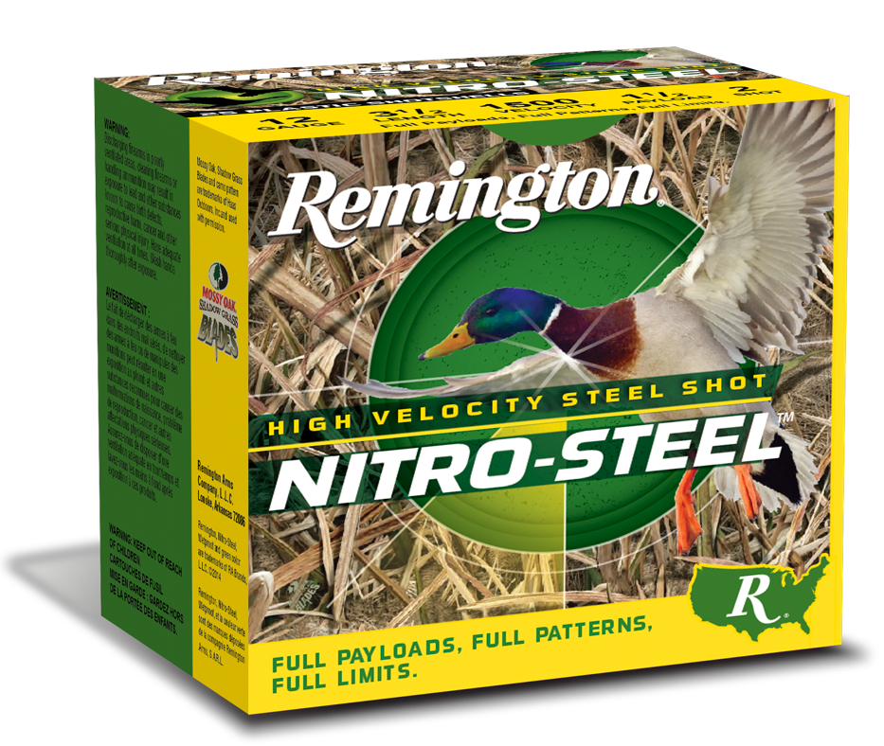
ORDER # | DESCRIPTION | UPC | MSRP
20853 | 10GA 3-1/2IN 1-1/2OZ 2 | 0-47700-51750-6 | $47.99
20803 | 12GA 2-3/4IN 1-1/8OZ 4 | 0-47700-34200-9 | $33.99
20650 | 12GA 2-3/4IN 1-1/4OZ BB | 0-47700-04740-9 | $33.99
20654 | 12GA 2-3/4IN 1-1/4OZ 2 | 0-47700-04760-7 | $33.99
20658 | 12GA 2-3/4IN 1-1/4OZ 4 | 0-47700-04780-5 | $33.99
20794 | 12GA 3IN 1-1/4OZ BB | 0-47700-15410-7 | $32.99
20796 | 12GA 3IN 1-1/4OZ 1 | 0-47700-15420-6 | $32.99
20798 | 12GA 3IN 1-1/4OZ 2 | 0-47700-15430-5 | $32.99
20800 | 12GA 3IN 1-1/4OZ 3 | 0-47700-15440-4 | $32.99
20802 | 12GA 3IN 1-1/4OZ 4 | 0-47700-15450-3 | $32.99
20852 | 12GA 3IN 1-3/8OZ T | 0-47700-15470-1 | $32.99
20856 | 12GA 3IN 1-3/8OZ BB | 0-47700-15490-9 | $32.99
20860 | 12GA 3IN 1-3/8OZ 2 | 0-47700-15510-4 | $32.99
20864 | 12GA 3IN 1-3/8OZ 4 | 0-47700-15530-2 | $32.99
20837 | 12GA 3-1/2IN 1-1/2OZ BB | 0-47700-51770-4 | $40.99
20839 | 12GA 3-1/2IN 1-1/2OZ 2 | 0-47700-51780-3 | $40.99
20941 | 16GA 2-3/4IN 15/16OZ 2 | 0-47700-34480-5 | $41.99
20943 | 16GA 2-3/4IN 15/16OZ 4 | 0-47700-34490-4 | $41.99
20769 | 20GA 3IN 1OZ 4 | 0-47700-51800-8 | $34.99

