NITRO TURKEY
Extra-hard lead shot meets next-level patterning at a value price. With a super full choke, Nitro Turkey patterns at over 80% in the kill zone.
FEATURES
- Unique manufacturing process yields shot that is as hard and round as copper-plated shot
- Will pattern as well as other copper-plated, buffered loads without the higher cost
- Specially blended powder recipe
- Advanced Power Piston® one-piece wad
- Delivers a full 1 7/8 oz. payload at 1210 fps
- 80% pattern densities
- Outstanding knockdown power
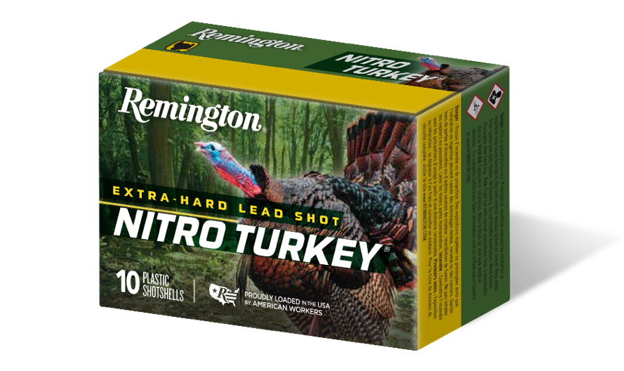
ORDER # | DESCRIPTION | UPC | MSRP
26688 | 12GA 2-3/4IN 1-1/2OZ 5 | 0-47700-50300-4 | $12.99
26690 | 12GA 2-3/4IN 1-1/2OZ 4 | 0-47700-50380-6 | $13.99
26693 | 12GA 3IN 1-7/8OZ 4 | 0-47700-34650-2 | $14.99
26695 | 12GA 3IN 1-7/8OZ 5 | 0-47700-34890-2 | $14.99
26697 | 12GA 3IN 1-7/8OZ 6 | 0-47700-34660-1 | $14.99
26710 | 12GA 3-1/2IN 2OZ 4 | 0-47700-50390-5 | $19.99
26708 | 12GA 3-1/2IN 2OZ 5 | 0-47700-50290-8 | $19.99
26712 | 12GA 3-1/2IN 2OZ 6 | 0-47700-50400-1 | $19.99
R26730 | 20GA 3IN 1-1/4OZ 5 | 0-47700-50310-3 | $13.99

