PERFORMANCE WHEELGUN
Put the hammer down or let your lever gun run with Remington’s Performance WheelgunTM. Loaded with every modern ballistic advantage, give your favorite revolver or levergun new life and top-tier performance with modern ammunition precisely crafted for your firearm’s needs. Using premier components, Performance Wheelgun gives ultimate consistency, accuracy and ironclad reliability at the range or in competition.
FEATURES
- Use in any appropriately chambered handgun or rifle, ideal for revolvers or leverguns
- Traditional bullet styles available including lead round nose, semi wad cutter, and target-master wad cutters
- Precision loaded with premier components including Remington Kleanbore® primers
- Proudly Loaded in the USA by American Workers
- Available in 32 S&W, 32 S&W Long, 357 Magnum, 38 S&W, 38 Special, 38 Short Colt, 44 S&W Special, and 45 Colt with a variety of bullet styles and grain weights

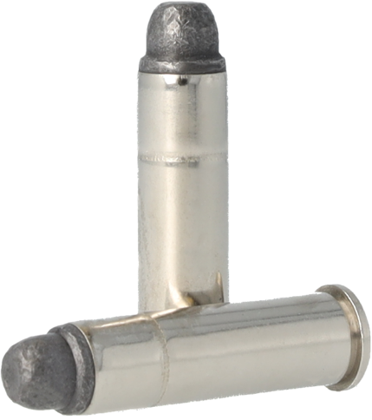

ORDER # | DESCRIPTION | UPC | MSRP
22206 | 32 S&W 88GR LEAD RN | 0-47700-47800-5 | $57.99
22210 | 32 S&W LONG 98GR LEAD RN | 0-47700-47810-4 | $57.99
22223 | 357 MAG 158GR LEAD SWC | 0-47700-47820-3 | $58.99
22278 | 38 S&W 146GR LEAD RN | 0-47700-47830-2 | $56.99
22267 | 38 SPL 148GR TMWC | 0-47700-49020-5 | $45.99
22271 | 38 SPL 158GR LEAD SWC | 0-47700-49030-4 | $45.99
22281 | 38 SPL 158GR LEAD RN | 0-47700-47840-1 | $45.99
22273 | 38 SHORT COLT 125GR LEAD RN | 0-47700-47850-0 | $61.99
22333 | 44 S&W SPL 246GR LEAD RN | 0-47700-47820-3 | $80.99
22338 | 45 COLT 225GR LEAD SWC | 0-47700-49040-3 | $72.99
22340 | 45 COLT 250GR LEAD RN | 0-47700-47870-8 | $72.99

