PREMIER BISMUTH
New Remington Premier Bismuth lets you hit harder and farther. Loaded with deadly HEVI-BISMUTHTM, the dense blended shot flies farther with an increased retained energy vs steel, giving you greater performance at greater distances. Premier Bismuth is loaded with top-tier Remington components and is just as lethal in the marsh as it is chasing pheasants.
FEATURES
- All-season load for waterfowl or upland hunts Non-toxic, 9.64g/cc density. Hits like lead
- Superior to steel. 22% more dense, 44% more downrange energy Available in 12, 20, 16, 28GA, .410
- Safe to shoot in all barrels, including vintage shotguns
- Loaded with HEVI-BISMUTH, which is proudly alloyed and cast in the USA
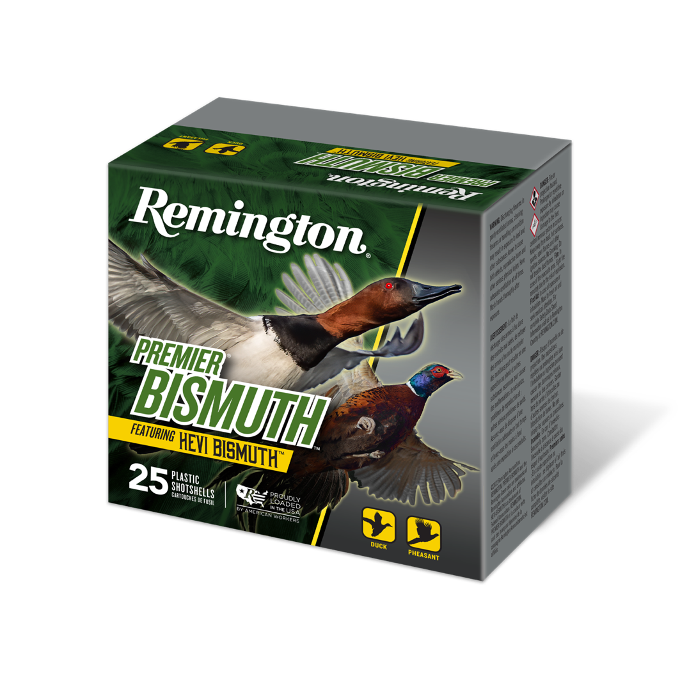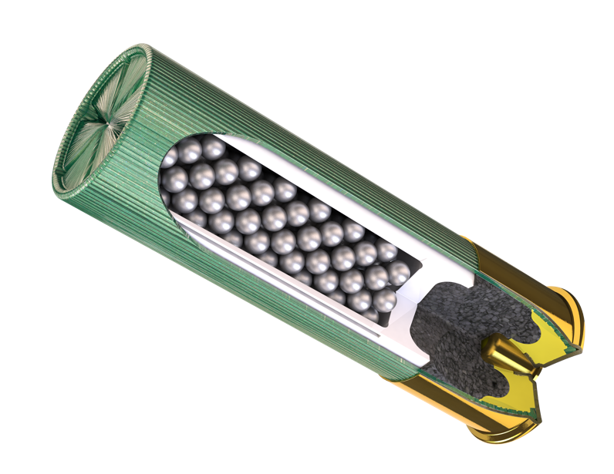
ORDER # | DESCRIPTION | MSRP
R20500 | 12GA 3" 1 3/8OZ 2 BISMUTH | $70.99
R20501 | 12GA 3" 1 3/8OZ 5 BISMUTH | $70.99
R20503 | 12GA 2 3/4" 1 1/4OZ 2 BISMUTH | $63.99
R20505 | 12GA 2 3/4" 1 1/4OZ 5 BISMUTH | $63.99
R20507 | 20GA 3" 1 1/8OZ 2 BISMUTH | $63.99
R20508 | 20GA 3" 1 1/8OZ 5 BISMUTH | $63.99
R20509 | 20GA 2-3/4 1 OZ 5 BISMUTH | $57.99
R20511 | 16GA 2.75IN 1 1/8OZ 4 BISMUTH | $74.99
R20513 | 28GA 2.75IN 7/8OZ 4 BISMUTH | $74.99
R20514 | 410 Bore 3IN 9/16OZ 4 BISMUTH | $60.99

