PREMIER® SCIROCCO
Big game beware because the remarkable Scirocco® bullet by Swift™ is coming for you. As the leader in bonded, tipped bullets, Scirocco delivers the highest ballistic coefficient, the flattest trajectory, and unsurpassed accuracy. Combined with maximum retained energy and superior weight retention, it’s unquestionably the toughest polymer tipped bullet on bucks, bulls, and boars at all ranges. Powerful performance. Ultimate accuracy.
FEATURES
- PRECISION-SHAPED POLYMER TIP - Expands reliably for lethal results
- JACKET AND CORE LOCKED TOGETHER - Features the most advanced bonded bullet design
- SLEEK PROFILE & BOAT TAIL BASE - Delivers optimal flight and trajectory, retains initial velocity and energy
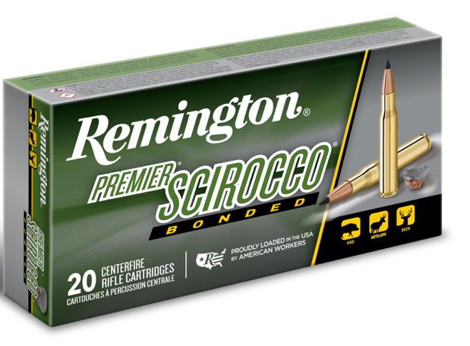
ORDER # | DESCRIPTION | UPC | MSRP
29320 | 243 WIN 90GR SWIFT SCIROCCO BONDED | 0-47700-35900-7 | $66.99
29322 | 270 WIN 130GR SWIFT SCIROCCO BONDED | 0-47700-35030-1 | $66.99
29316 | 7MM REM MAGNUM 150GR SWIFT SCIROCCO BONDED | 0-47700-35390-6 | $76.99
29335 | 7MM REM ULTRA MAG 150GR SWIFT SCIROCCO BONDED | 0-47700-39170-0 | $89.99
29328 | 30-06 SPRG 180GR SWIFT SCIROCCO BONDED | 0-47700-35050-9 | $69.99
29318 | 30-06 SPRG 150GR SWIFT SCIROCCO BONDED | 0-47700-35400-2 | $69.99
29344 | 6.5 CREEDMOOR 130GR SWIFT SCIROCCO BONDED | 0-47700-49770-9 | $67.99
29345 | 300 WSM 180GR SWIFT SCIROCCO BONDED | 0-47700-39150-2 | $77.99
R29330 | 300 WIN MAG 180GR SWIFT SCIROCCO BONDED | 0-47700-35080-6 | $74.99
27950 | 300 REM ULTRA MAG 150GR SWIFT SCIROCCO BONDED | 0-47700-35290-9 | $103.99
27936 | 300 REM ULTRA MAG 180GR SWIFT SCIROCCO BONDED | 0-47700-35010-3 | $103.99
29332 | 308 WIN 165GR SWIFT SCIROCCO BONDED | 0-47700-35060-8 | $67.99

