REMINGTON CIGARS
Handcrafted by Gurkha® Cigars, celebrate good hunts, good friends, and good times with Remington’s new line of premier cigars. Made for all palates, Remington cigars are nothing short of an experience to remember. Aged, aromatic, and available in two full-flavor blends, the Mountaineer or the Hunter. Remington cigars are available in multiple shapes and sizes. Soon to be found at premier ranges, retailers and hunting lodges across America.
FEATURES
- Handcrafted by Gurkha, the founder of the ultra-premium cigar category
- Habano Toro, Habano Robusto, Connecticut Toro or Connecticut Robusto
- Available in multiple package options, including 20-cigar boxes or 6-cigar sampler baggies
- 6-cigar sampler baggies sealed for long lasting enjoyment, easily portable for a trip to the range or deer camp
- Coming soon to premier ranges, retailers and hunting lodges
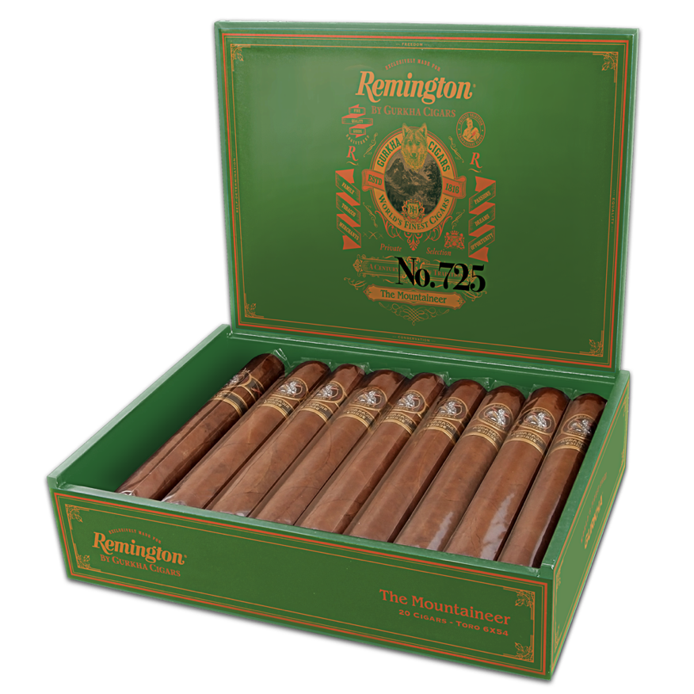
ORDER # | DESCRIPTION | PACKAGING | MSRP
RMMGHCS | Remington Mountaineer Habano Cigar Sampler | 6-Cigar Sampler | $79.68
RMMGHTC | Remington Mountaineer Habano Toro Cigars | 20-Cigar Box | $289.00
RMMGHRC | Remington Mountaineer Habano Robusto Cigars | 20-Cigar Box | $289.00
RMHGCCS | Remington Hunter Connecticut Cigar Sampler | 6-Cigar Sampler | $79.68
RMHGCTC | Remington Hunter Connecticut Toro Cigars | 20-Cigar Box | $289.00
RMHGCRC | Remington Hunter Connecticut Robusto Cigars | 20-Cigar Box | $289.00

