SUBSONIC RIFLE

Breakthrough accuracy that never breaks the sound barrier. Subsonic rifle loads are engineered for optimal performance when paired with a suppressor. Loaded with premier components under stringent quality controls, these loads deliver consistent, subsonic velocity to prevent supersonic cracks. Bullets in full profile jacketed and open-tip flat base eliminate lead buildup in suppressor port

FEATURES

- Specifically designed for optimal performance when paired with a silencer
- Tight velocity control to eliminate supersonic cracks

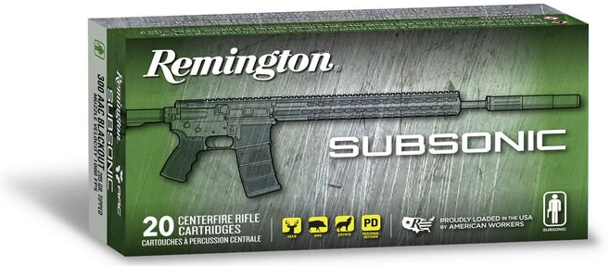

ORDER # | DESCRIPTION | UPC | MSRP
28430 | 300 AAC BLACKOUT 220GR | 0-47700-47990-3 | $33.99

