UMC HANDGUN
All UMC handgun ammunition is American-made in Lonoke, Arkansas, using first-quality, factory-fresh brass and clean-shooting Kleanbore® primers to provide the best value for practice, personal defense and hunting. UMC handgun ammunition offers the choice of full metal jacket, soft point, and jacketed hollow point bullets in several popular handgun calibers. You'd be hard-pressed to find a better value anywhere.
FEATURES
- Econominal, best value for high volume shooting
- First-quality, factory-fresh brass and clean-shooting KleanBore® Primers

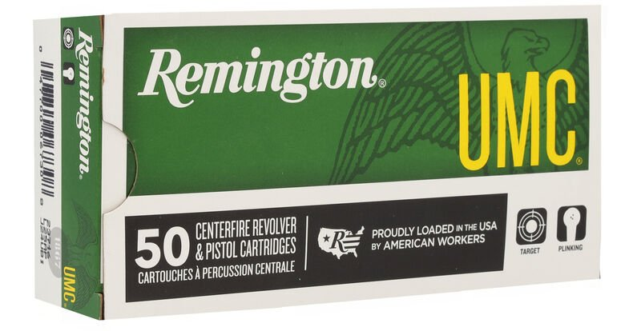

ORDER # | DESCRIPTION (QTY. 50) | UPC | MSRP
23716 | UMC HANDGUN 25 AUTO FMJ 50GR | 0-47700-06730-8 | $42.99
R20015 | NEW UMC HANDGUN 30 SUPER CARRY | 0-47700-48720-5 | $33.99
23704 | UMC HANDGUN 32 AUTO FMJ 71GR | 0-47700-16920-0 | $46.99
23738 | UMC HANDGUN 357 MAGNUM JSP 125GR | 0-47700-16900-2 | $56.99
23752 | UMC HANDGUN 9MM LUGER JHP 115GR | 0-47700-35650-1 | $40.99
23718 | UMC HANDGUN 9MM LUGER FMJ 124GR | 0-47700-06740-7 | $24.99
23728 | UMC HANDGUN 9MM LUGER FMJ 115GR | 0-47700-06980-7 | $24.99
23732 | UMC HANDGUN 9MM LUGER FMJ 147GR | 0-47700-35590-0 | $25.99
R23720 | UMC HANDGUN 380 AUTO FMJ 95GR | 0-47700-06750-6 | $33.99
23722 | UMC HANDGUN 38 SUPER +P FMJ 130GR | 0-47700-06760-5 | $54.99
23754 | UMC HANDGUN 38 SPECIAL +P SJHP 125GR | 0-47700-35640-2 | $37.99
23724 | UMC HANDGUN 38 SPECIAL LRN 158GR | 0-47700-06770-4 | $40.99
23730 | UMC HANDGUN 38 SPECIAL FMJ 130GR | 0-47700-07610-2 | $40.99
23706 | UMC HANDGUN 10MM AUTO FMJ 180GR | 0-47700-16930-9 | $47.99
23734 | UMC HANDGUN 357 SIG FMJ 125GR | 0-47700-16980-4 | $79.99
23742 | UMC HANDGUN 40 S&W FMJ 180GR | 0-47700-07730-7 | $34.99
23746 | UMC HANDGUN 40 S&W FMJ 165GR | 0-47700-17250-7 | $34.99
23694 | UMC HANDGUN 40 S&W JHP 180GR | 0-47700-35670-9 | $48.99
23744 | UMC HANDGUN 44 REMINGTON MAGNUM JSP 180GR | 0-47700-16910-1 | $66.99
23818 | UMC HANDGUN 45 AUTO FMJ 185GR | 0-47700-36180-2 | $39.99
23726 | UMC HANDGUN 45 AUTO FMJ 230GR | 0-47700-06780-3 | $39.99
23696 | UMC HANDGUN 45 AUTO JHP 230GR | 0-47700-35680-8 | $50.99
R20016 | NEW UMC HANDGUN 327 FEDERAL MAGNUM JSP 100GR | 0-47700-42240-4 | $50.99
ORDER # | DESCRIPTION (QTY. 100) | UPC | MSRP
R23970 | UMC HANDGUN 357 MAGNUM SJHP 125GR | 0-47700-39140-3 | $112.99
23753 | UMC HANDGUN 9MM LUGER JHP 115GR | 0-47700-38210-4 | $81.99
23765 | UMC HANDGUN 9MM LUGER FMJ 115GR | 0-47700-36240-3 | $49.99
R23974 | UMC HANDGUN 380 AUTO JHP 88GR | 0-47700-38640-9 | $84.99
23771 | UMC HANDGUN 38 SPECIAL +P SJHP 125GR | 0-47700-36320-2 | $76.99
23687 | UMC HANDGUN 40 S&W JHP 180GR | 0-47700-38250-0 | $96.99
23795 | UMC HANDGUN 40 S&W FMJ 180GR | 0-47700-38270-8 | $70.99
23797 | UMC HANDGUN 45 AUTO FMJ 230GR | 0-47700-38280-7 | $78.99
23689 | UMC HANDGUN 45 AUTO JHP 230GR | 0-47700-38240-1 | $101.99
ORDER # | DESCRIPTION (QTY. 250) | UPC | MSRP
23777 | UMC HANDGUN 9MM LUGER FMJ 115GR | 0-47700-36420-9 | $125.99
23721 | UMC HANDGUN 380 AUTO FMJ 95GR | 0-47700-38610-2 | $171.99
23731 | UMC HANDGUN 38 SPECIAL FMJ 130GR | 0-47700-38600-3 | $202.99
23779 | UMC HANDGUN 40 S&W FMJ 180GR | 0-47700-36430-8 | $176.99
23773 | UMC HANDGUN 40 S&W FMJ 165GR | 0-47700-36260-1 | $176.99
23781 | UMC HANDGUN 45 AUTO FMJ 230GR | 0-47700-36440-7 | $197.99
ORDER # | DESCRIPTION (BUCKET) | UPC | MSRP
23635 | UMC HANDGUN 9MM LUGER FMJ 115GR | 0-47700-47260-0 0-47700-47161-7 | $175.99
R23978 | UMC HANDGUN 380 AUTO FMJ 95GR | 0-47700-47710-7 0-47700-47711-4 | $205.99
23669 | UMC HANDGUN 38 SPECIAL FMJ 130GR | 0-47700-40870-5 0-47700-40874-3 | $242.99
23976 | UMC HANDGUN 40 S&W FMJ 180GR | 0-47700-47560-8 0-47700-47564-6 | $212.99
23817 | UMC HANDGUN 45 AUTO FMJ 230GR | 0-47700-47570-7 0-47700-47574-5 | $158.99
ORDER # | DESCRIPTION (BULK) | UPC | MSRP
23659 | UMC HANDGUN 9MM LUGER FMJ 115GR – 500 COUNT | 0-47700-47501-1 | $251.99
23649 | UMC HANDGUN 45 AUTO FMJ 230GR – 500 COUNT | 0-47700-41411-9 | $395.99
23647 | UMC HANDGUN 40 S&W FMJ 180GR – 650 COUNT | 0-47700-41401-0 | $460.99
23645 | UMC HANDGUN 9MM LUGER FMJ 115GR – 1000 COUNT | 0-47700-41391-4 | $502.99

