ULTIMATE DEFENSE SHOTSHELL™
When the stakes are the highest, call on the ultimate in defensive rounds from Remington. Ultimate DefenseTM Buckshot delivers massive knockdown power and devastating patterns. At common defensive short ranges, patterns in smoothbore barrels are tight and effective for one-shot confidence. Offered in full-power and reduced recoil load options.
FEATURES
- Shotshell or rifle, the Remington Ultimate Defense line of ammunition has an offering to protect you
- 12 and 20GA loads available in full-power and reduced recoil options
- Manufactured to exacting tolerances for smooth feeding in both pump-action and autoloading shotguns
- Maximize your .45/.410 revolver’s effectiveness with Ultimate Defense’s .410 buckshot load
- Buckshot offered in 12GA, 20GA and .410 bore, from #4 buck to #000
- Ultimate Defense Rifle Bonded – Featuring Core-Lokt Ultra Bonded® projectiles, flash-suppressed propellants and Kleanbore® primers for trusted stopping power, low-light performance, and ultimate reliability
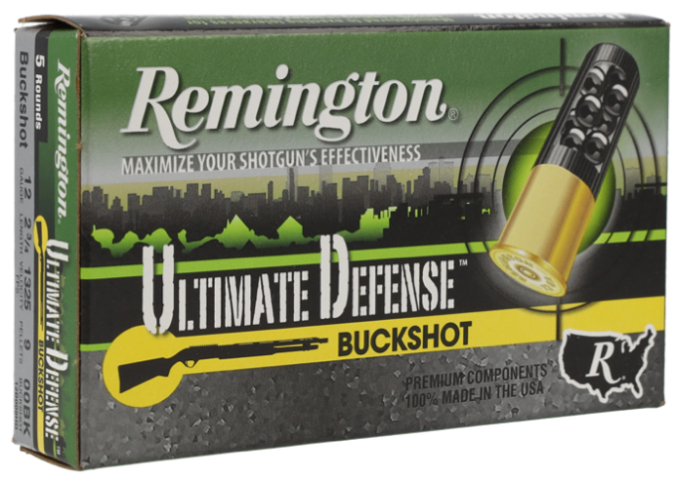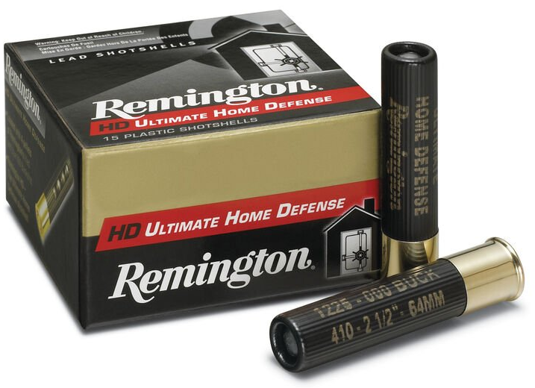
ORDER # | DESCRIPTION | UPC | MSRP
20713 | 12GA 2-3/4IN 9 PEL 00 BUCKSHOT | 0-47700-51980-7 | $9.99
20711 | 12GA 2-3/4IN 8 PEL 00 BUCKSHOT | 0-47700-51990-6 | $9.99
20633 | 12GA 3IN 4DRAM 15 PEL 00 BUCKSHOT | 0-47700-52740-6 | $10.99
20639 | 12GA 3IN 4 DRAM 41 PEL 4 BUCKSHOT | 0-47700-52750-5 | $10.99
20637 | 12GA 2-3/4IN 21PEL 4 BUCKSHOT | 0-47700-52760-4 | $8.99
20681 | 20GA 2-3/4IN 17PEL 3 BUCKSHOT | 0-47700-52770-3 | $8.99
20697 | 410GA 2-1/2IN 4PEL 000 BUCKSHOT | 0-47700-51270-9 | $27.99
20707 | 410GA 3IN 5PEL 000 BUCKSHOT | 0-47700-51250-1 | $30.99

