KASPA™ Illuminated Reticle Scopes
Now you can wring every second of shooting light out of your hunt and every ounce of performance from your budget with the new Weaver® KASPA™ Series Illuminated Reticle Scopes. KASPA Illuminated Reticle riflescopes offer tremendous value at budget prices. Engineered to the same standards as all Weaver optics, these U.S. engineered scopes deliver bright clear images, fog-free viewing and illuminated center crosshairs that make target acquisition quick and easy under harsh bright sun and low-light conditions.

Features & Benefits
- Illuminated center crosshairs shine during prime hunting times
- Fully multi-coated lenses for edge-to-edge clarity
- Rugged one-piece tube construction
- Purged nitrogen-filled tubes eliminate internal fogging
- One-inch tube allows multiple mounting options
- Some models feature side-focus parallax adjustment
- Illuminated Dual-X reticle

Model No. Description UPC MSRP
849804 KASPA 3-9x40mm Illuminated Reticle 0-76683-49804-5 $279.95
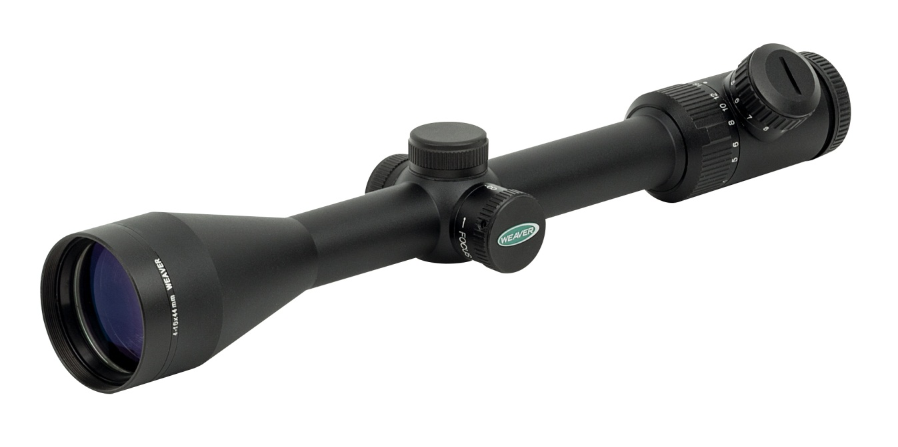
849812 KASPA 4-16x44mm Illuminated Reticle SF 0-76683-89804-3 $319.95
Model 849812

