Trophy® Cam HD – No Glow | Low Glow
New Pre-set menu choices based on location and illuminated 5-way button control panel make these units the best Trophy Cam ever. Field-proven design with a removable “ARD” anti-reflection LED cover, strengthened cable lock channel and an improved latch for maximum ruggedness. These models provide stunning images with a super-fast 0.2-second trigger speed, hyper 0.5s recovery rate, extended nighttime photo range and true 1-year battery life. The New Trophy Cam HD No Glows are exactly what hunters have been waiting for.

TROPHY CAM HD – NO GLOW  - Black LEDs invisible to both  game and other hunters  - Lightning fast 0.2s trigger speed  - Incredible 0.5s recovery rate  - 100 Feet Detection Distance  - Pre-set menus and backlit 5-way  buttons for easy setup  - Dynamic video  - True one-year battery life for all season scouting  - Unparalleled night vision distance and brightness  Part No.: 119876C (TAN) | 119877C (CAMO)  Description: 20MP | 24MP Trophy Cam HD No Glow  UPC: 0-29757-19876-1 | 0-29757-19877-8  MSRP: $250.45 | $287.95  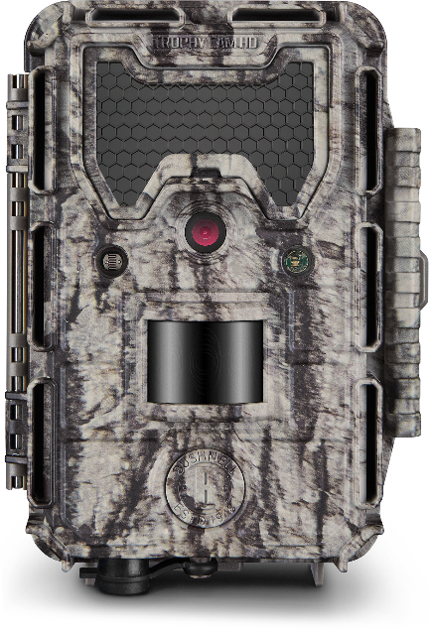  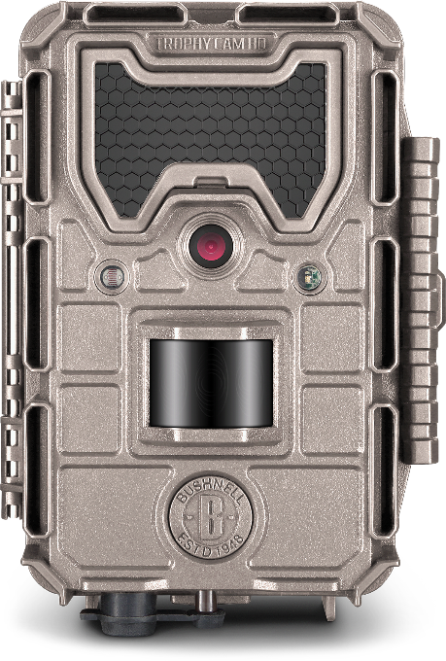  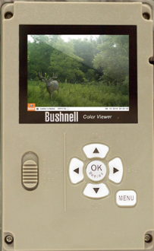  COLOR VIEWER | TROPHY CAM HD – LOW GLOW  - Low-Glow LEDs feature brightest night vision offered in Trophy Cam line  - Lightning fast 0.2s trigger speed  - Incredible 0.5s recovery rate  - 100 Feet Detection Distance  - Pre-set menus and backlit 5-way  buttons for easy setup  - Dynamic video  - True one-year battery life for all season scouting  - Unparalleled night vision distance and brightness  Part No.: 119874C (TAN) | 119875C (CAMO)  Description: 20mp | 24 MP Trophy Cam HD Low Glo  UPC: 0-29757-19874-7 | 0-29757-19875-4  MSRP: $225.45 | $250.95  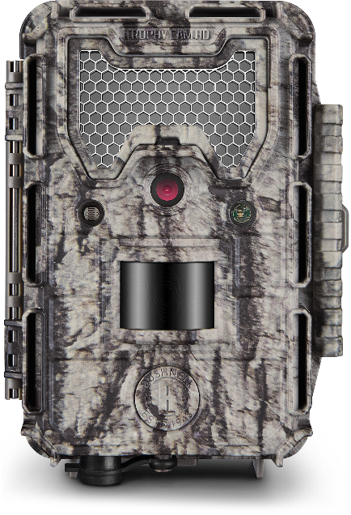  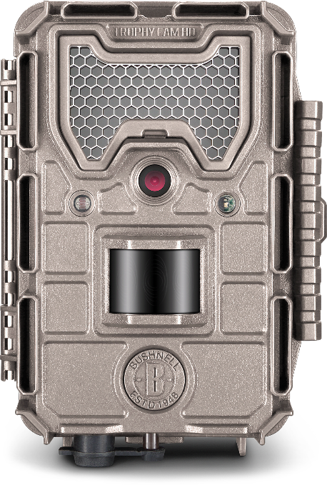  COLOR VIEWER

