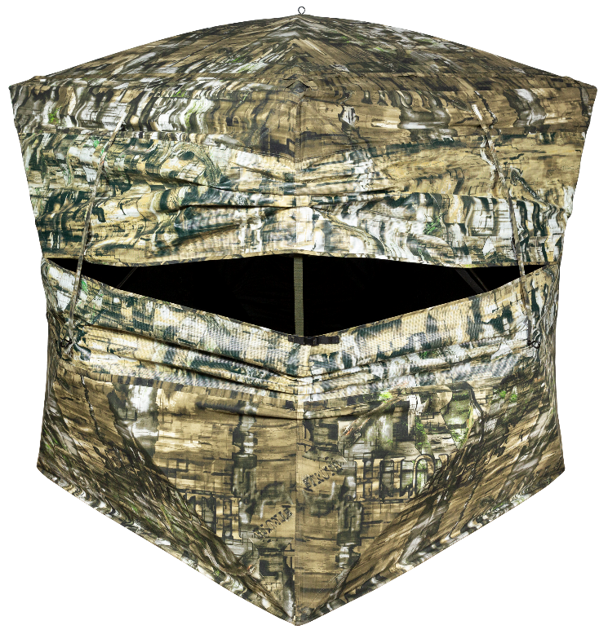
SKU | NAME | UPC | UPP
65163 | Double Bull SurroundView Max Ground Blind | 0-10135 65163-3 | $399.99
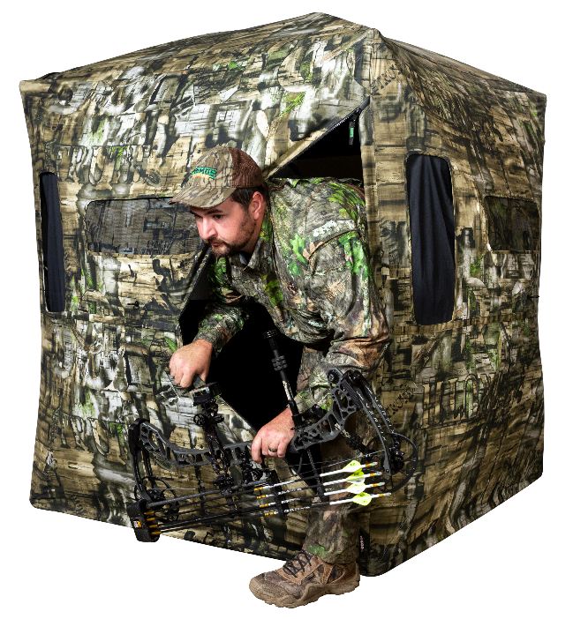
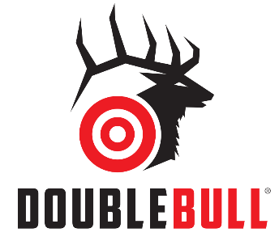
=
Bungee/Zipper door option

- Triangle door with zipper and bungee for quieter option while entering or exiting the blind
- 180° Full front window with silent slide window closures
- 180° of SurroundView viewing capability
- Sun Visor for early morning and late evening hunting times
- Hub to Hub: 70”; Height: 67”; Floor Space: 56”x 56”
- Limited Lifetime Warranty
Continuing the SurroundView Line; the SurroundView Max offers some great new features; including a door that offers the option of zipping up or bungees for quieter entry and exit. The 180° viewing capabilities with a built-in sun visor allows for great visibility during all times of the day while allowing you to stay hidden.
Double Bull SurroundView™ Max
Ground Blind

