SKU | NAME | UPC | AVG RETAIL
PS2961 | Early Bird Box Call | 0-1013502961-6 | $29.95
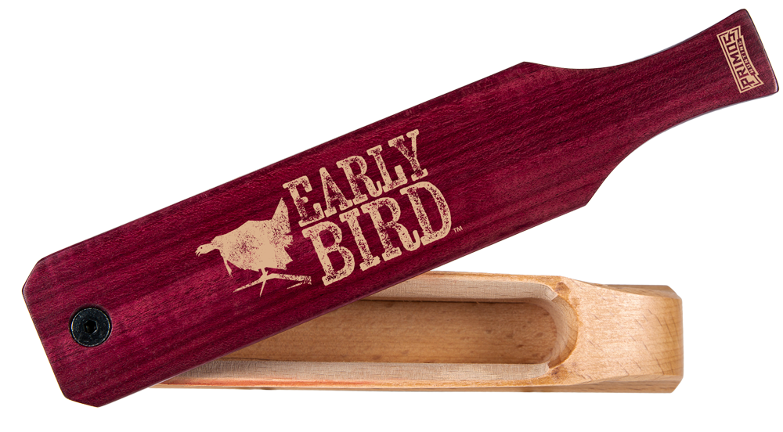
- Purple Heart Paddle / Hardwood Box
- Sanded by Hand
- Double-sided box hand tuned for two different sounds
- Available 12/1/19

Primos Early Bird Box Call is a double-sided box, creating tones only Purple Heart can offer, that look and feel as good as it sounds. Purple Heart is one of the most durable and sturdiest woods in the world. Not only is it exotic and rare due to its beautiful color, but is also water resistant. For easy yelps, no extra pressure is needed with its paddle, just drag it over the hardwood box and get combination of thick lows, and sharp high notes every time. This box call, sanded by hand, turns into two different hens, so it’s like getting two calls in one.

Early Bird Box Call

