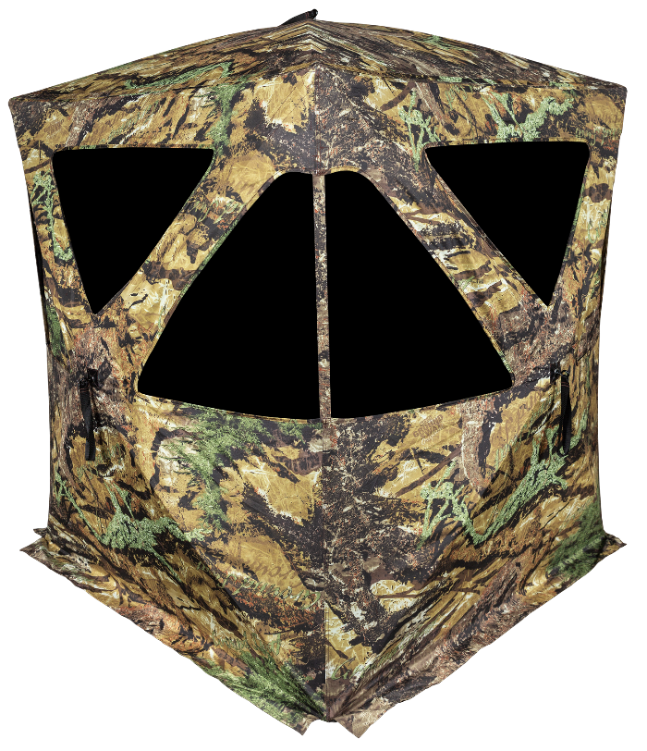
Primos HideSight Ground Blind

SKU | NAME | UPC | AVG RETAIL
65109 | Primos HideSight Ground Blind | 0-10135 65109-1 | $199.99
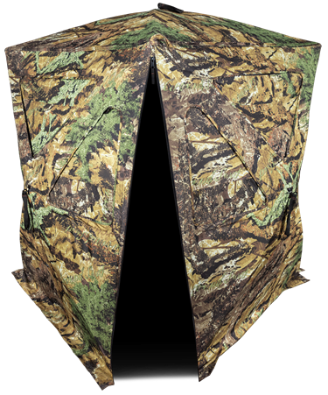
Wrapped in Primos Ground Swat camouflage, these blinds disappear into any terrain you put them in. The 300D Polyester fabric is durable and has a low sheen to help further blend it into its surroundings. The top edge of the blind is lined with Brush Deception™ holders to hold in sticks, branches, and leaves. Don’t just go to the woods on your next hunting trip, go in with the Hidesight blind.
- Hub to Hub: 70”
- Height 67”
- Floor Space: 56” x 56”
- Weight: 20 lbs

