SKU | NAME | UPC | MSRP
892 | Bottonlamd Phat Lady | 0-1013500892-5 | $34.95
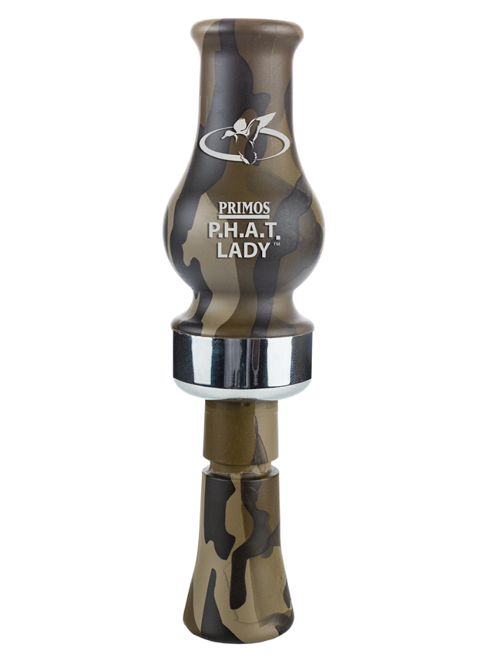
The P.H.A.T. Lady™ is an Arkansas style, single-reed call that features a large sound port designed for increased volume, which is ideal for open water conditions. The ducks know it’s over when The P.H.A.T. Lady™ sings!
- Mossy Oak® Bottomland Camo
- P.H.A.T. = Pretty, Hot And Tempting
- Rose Polycarbonate, Arkansas style single-reed
- Polished band
- Features a large sound port designed for increased volume
- Perfect for open water
Bottomland Phat Lady

