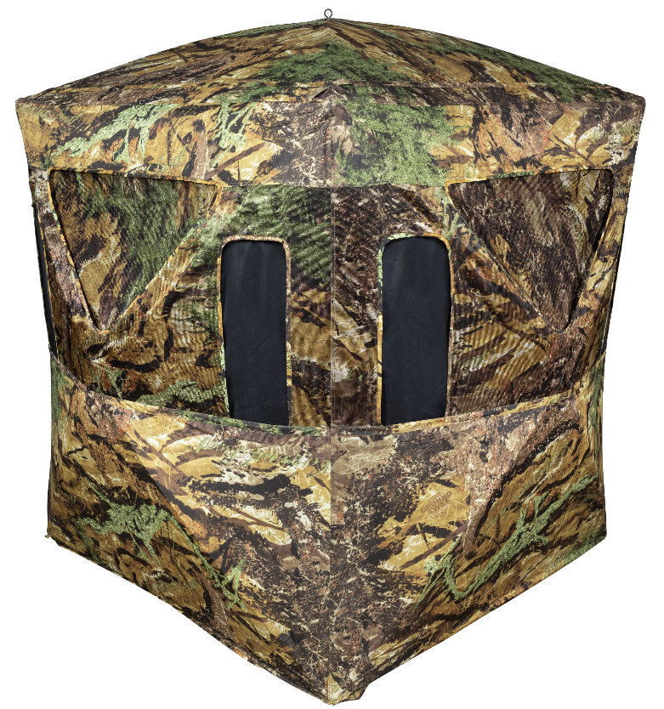
Primos Smokescreen Ground Blind

SKU | NAME | UPC | AVG RETAIL
65111 | Primos Smokescreen Ground Blind | 0-10135 65111-4 | $299.99
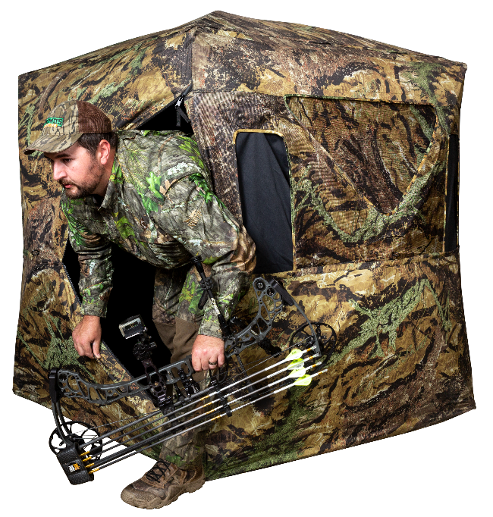
- New material allows hunters to see out while not allowing game to see in
- Triangle door
- 300D Brushed Polyester
- Aluminum Hubs
- Ground Swat Camo
- Hub to Hub: 70”; Height: 67”; Floor Space: 56” x 56”

Introducing the next in line for the Primos Ground Blind category. This Primos Smokescreen utilized one way see through technology that allows hunters to see out while not allowing game to see in! Coming with 7 shoot through ports and 3 max viewing windows this blind offers 270° of viewing capability as well as plenty of shooting opportunities. This blind offers maximum room for up to 3 people to sit comfortability while enjoying their hunt with an incredible view!

