SKU | NAME | UPC | MSRP
65150 | Surround View 360 | 0-10135-65150-3 | $499.99
65151 | Surround View 270 | 0-10135-65151-0 | $399.99
65152 | Surround View 180 | 0-10135-65152-7 | $299.99
Double BullⓇ SurroundView™ 360 | 270 | 180 Blinds

Introducing the PrimosⓇ Double BullⓇ SurroundView™ Blind. It’s the Blind Without A Blind Spot—constructed with exclusive one-way see through walls that let you see all of your surroundings without being seen. Now you can spot all the movement you miss with traditional blinds, yet remain just as concealed.

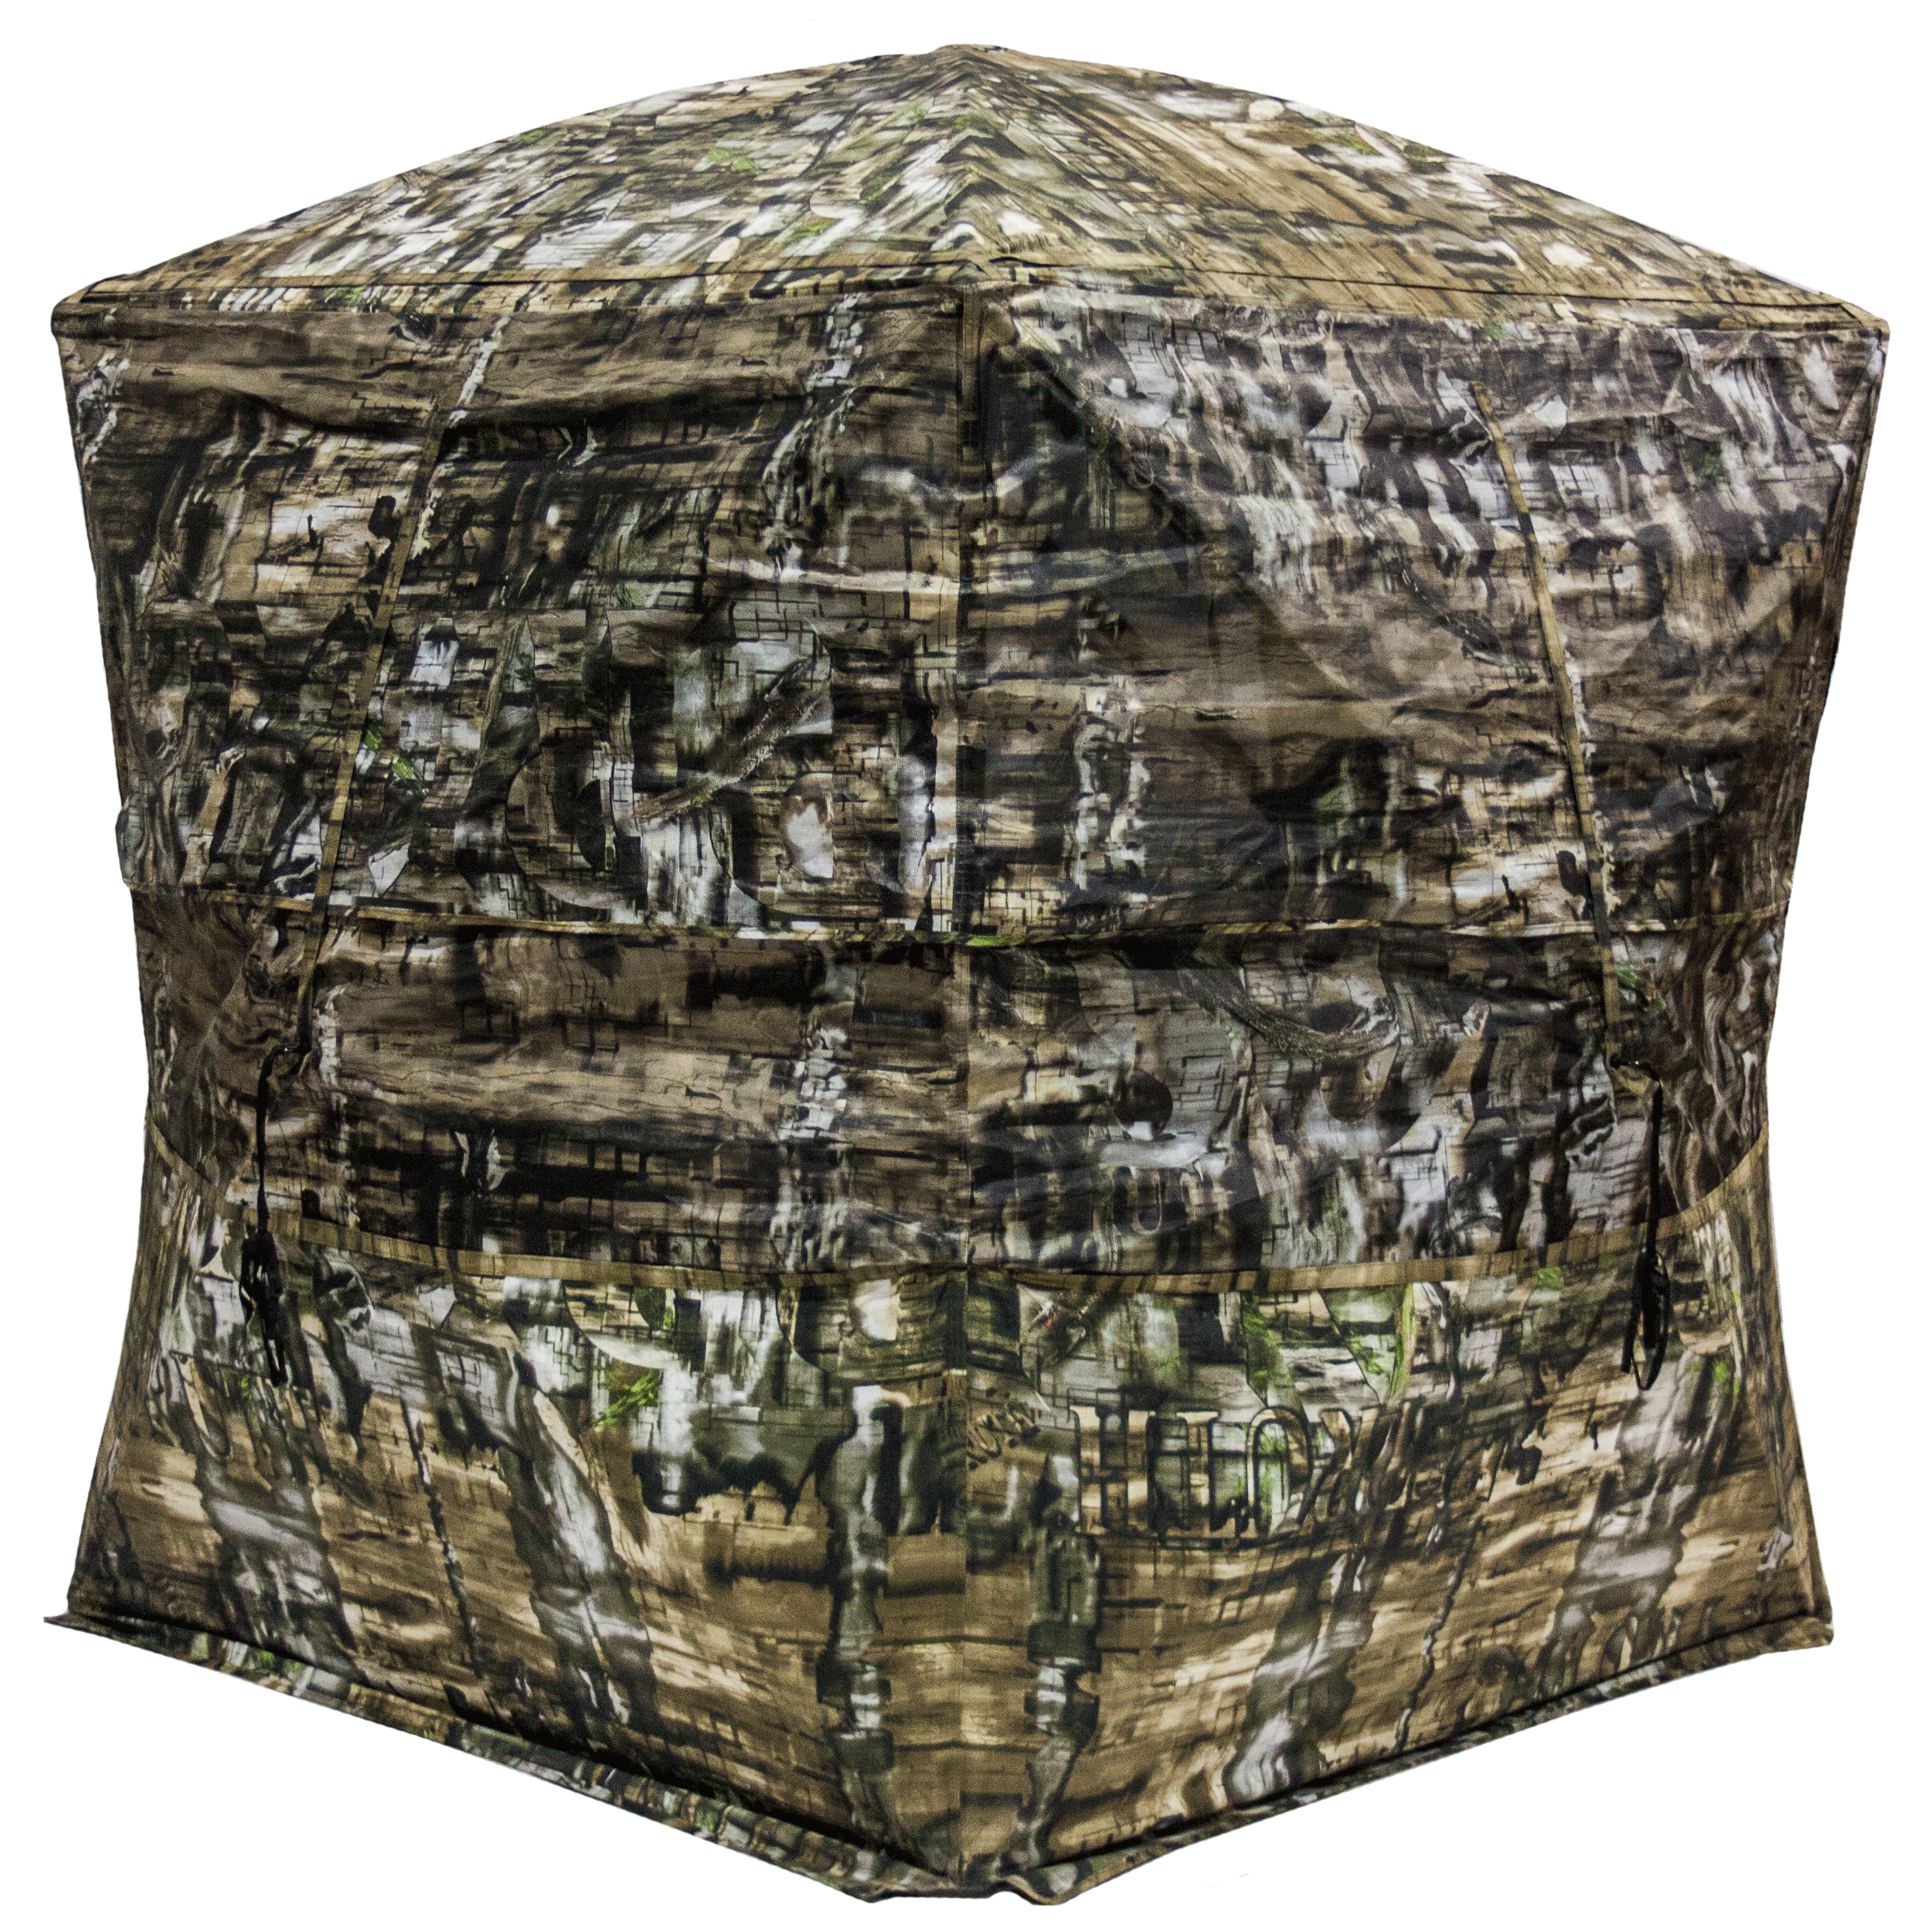
- Exclusive one-way see through camo walls
- 360° comes with four one-way see through walls with one movable black out wall to place on any wall you choose.
- 270° comes with three one-way see through walls and one rear blackout wall.
- 180° comes with two one-way see through walls and two rear blackout walls.
- Patented hub system for easy set up that’s extremely solid
- Legendary Double Bull Materials and Construction
- TRUTH camo specifically designed to hide ground blinds in any terrain
- Limited Lifetime Warranty

