Drag Strip Turkey Call
SKU | NAME | UPC | MSRP
2914 | Drag Strip Turkey Call | 0-10135-02914-2 | $39.99
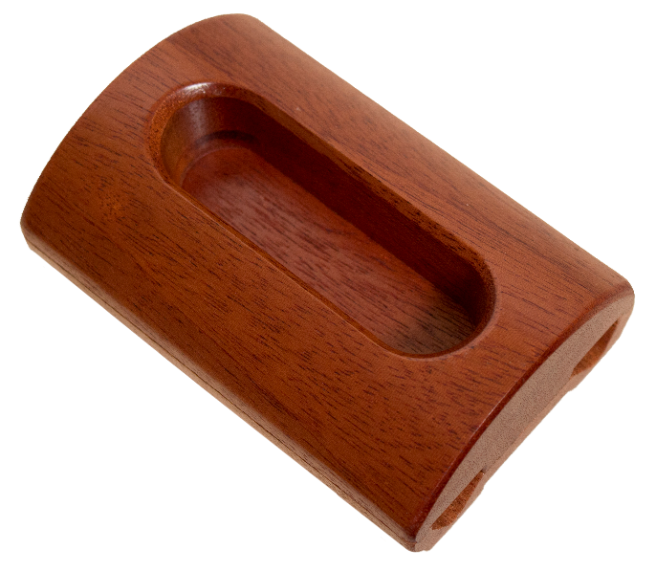
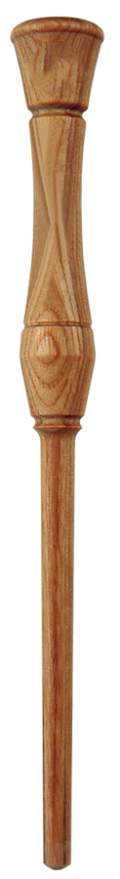
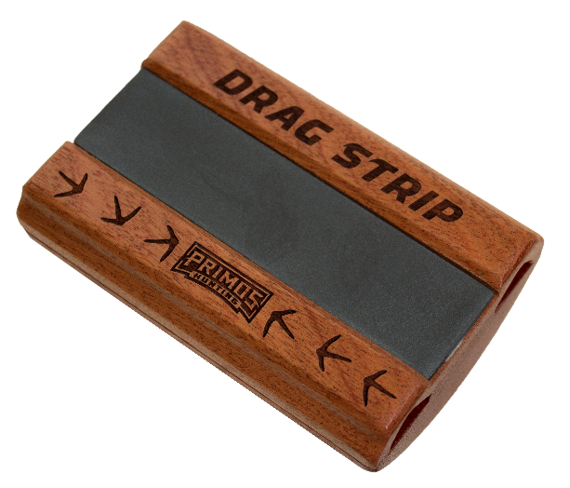
The PrimosⓇ Drag Strip™ is a modern version of an old school traditional call. The Drag Strip is made of CNC milled exotic hardwood and Pennsylvania slate. The design, with a built-in sound board and sound ports, fits perfectly in your hand to produce smooth yelps, purrs, clucks and cuts. It’s all topped off with laser engraving and a one piece CNC turned striker. With the Drag Strip in your hands, you’re ready to head to the woods.
- Resurrected traditional design
- Exotic hardwood and Pennsylvania slate
- CNC milled
- Laser engraved
- One pieced laminated striker

