**Proof** **™ Cellular Trail Camera**

(IMAGE NOT FINAL)

Primos Proof Cameras are known for their “Simple to Use” set up, the new Proof Cellular is no exception. It’s Simple Cellular that sends high quality images from the field to phone with one-button setup and no contracts. It works with any smartphone no matter your provider. Simple activation and data plans let you focus on the pictures and not the camera set up. Put it out, turn it on, and get the images sent instantly to your phone, it is just that simple.

**Camera Specifications:**

* 16MP HD Images
* 720p HD Video
* 6 Month Battery Life
* 0.2 Second Trigger Speed
* 10 second recovery rate

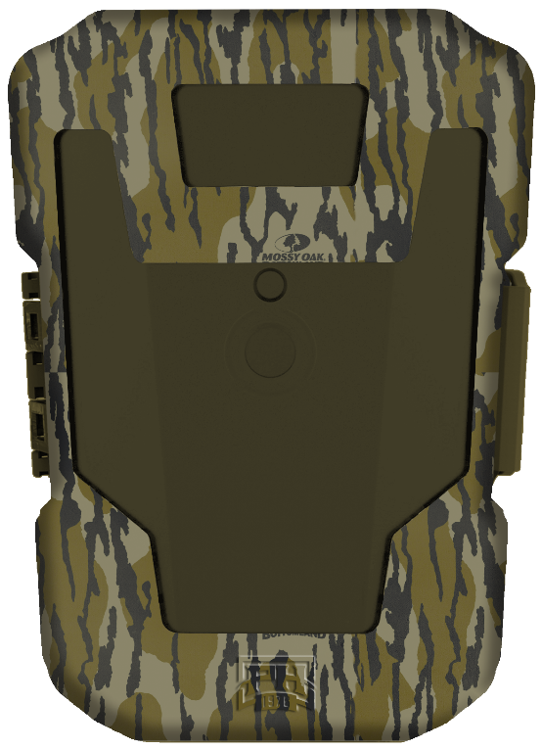

**Benefit:**

Better cellular coverage

More pictures of your quarry

Long range flash for superior night pictures

Complete weather info at the time of image capture

Quick and easy activation

Instantly see cellular signal

**Camera Features:**

* AT&T and Verizon Options
* 10 Second Image Recovery
* 100’ Low Glow Infrared Illumination
* Weather Data Image Tags
* One-Button Set Up
* Signal Meter