Proof Gen 2 - 01 | O2 | 03 BLACKOUT™
Every Proof Camera is built for one purpose: To give hunters the most reliable, most simple-to-use camera money can buy with all the functions that really matter and none of the extras that don’t. Now Primos new Proof Gen 2 line offers faster recovery, better detection distance, and best in class performance. With a faster 1-second recovery rate you’ll get more pics with fewer blanks. The new auto exposure feature means better light detection with no more whiteouts. Add in its illuminated sliding switches, 720 HD video and timelapse, plus a 1 year battery life and you’ll see nothing performs like the Proof Cam Gen 2. Without A Doubt.
PROOF GEN 2 | 01 FEATURES  - 12 megapixels  - 0.7 trigger speed  - 80 ft. night range  - Faster 1-second recovery rate for more pics with fewer blanks  - New auto exposure feature for better light detection with no more whiteouts  - Simple set-up  - Illuminated sliding switches  - 36 low glow LED’s  - 720P HD video and timelapse  - 1 year battery life on 8 AA Batteries  Part No.: 64054  Description: Proof Gen 2 | 01  UPC: 0-10135-00001-1  MSRP: $99.00  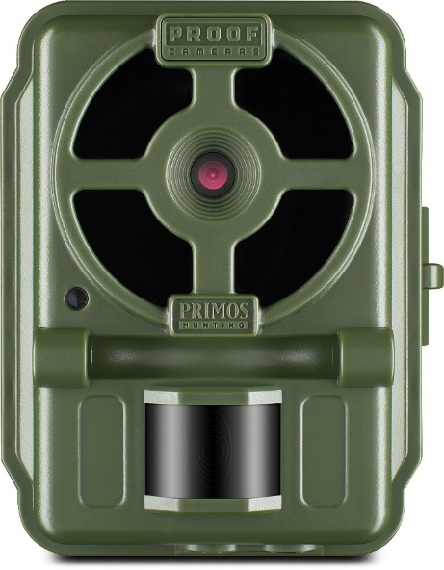 | PROOF GEN 2 | 02  FEATURES  - 16 megapixels  - 0.3 trigger speed  - 100 ft. night range  - Faster 1-second recovery rate  for more pics with fewer blanks  - New auto exposure feature for  better light detection with no  more whiteouts  - Simple set-up  - Illuminated sliding switches  - 36 low glow LED’s  - 720P HD video and timelapse  - 1 year battery life on 8 AA Batteries  Part No.: 64055  Description: Proof Gen 2 | 02  UPC: 0-10135-00002-8  MSRP: $129  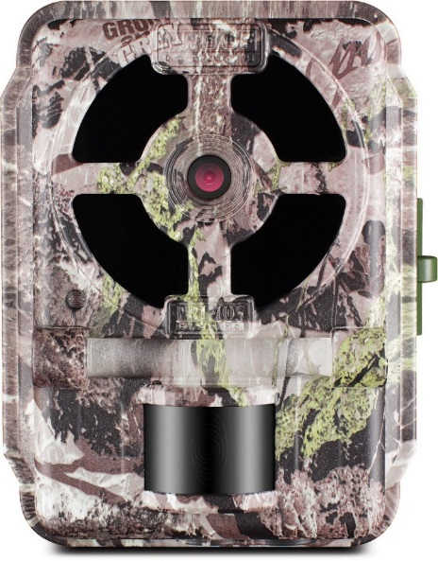 | PROOF GEN 2 | 03 BLACKOUT  FEATURES  - 16 megapixels  - 0.3 trigger speed  - 100 ft. night range  - Faster 1-second recovery rate  for more pics with fewer blanks  - New auto exposure feature for  better light detection with no  more whiteouts  - Simple set-up  - Illuminated sliding switches  - 60 BLACKOUT™ LED’s  - 720P HD video and timelapse  - 1 year battery life on 8 AA  Batteries  Part No.: 64056  Description: Proof Gen 2 | 03 BLACKOUT  UPC: 0-10135-00004-2  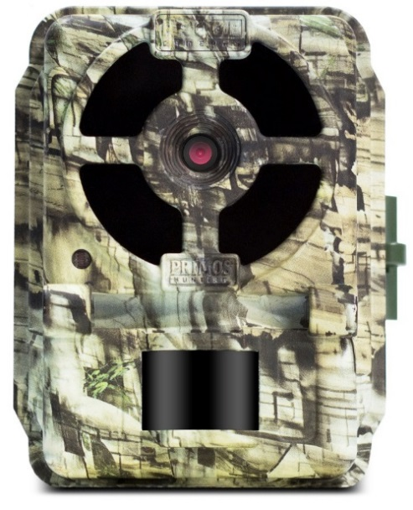  MSRP: $149

