Trigger Stick Accessories
SKU | NAME | UPC | MSRP
655101 | Trigger Stick Gen 3 Yoke | 0-10135-65501-3 | $10.95
655102 | Trigger Stick Gen 3 Camera Mount Yoke | 0-10135-65502-0 | $10.95
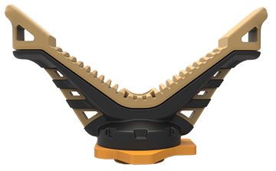
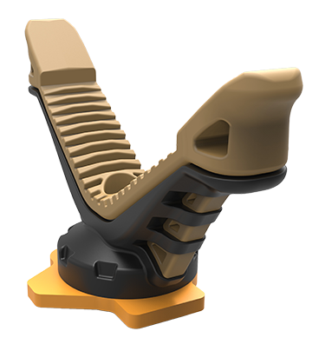
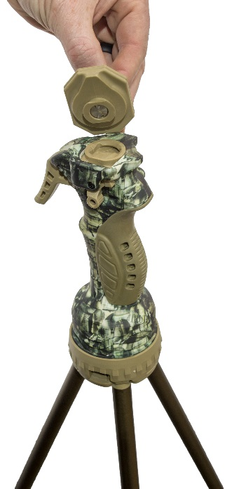
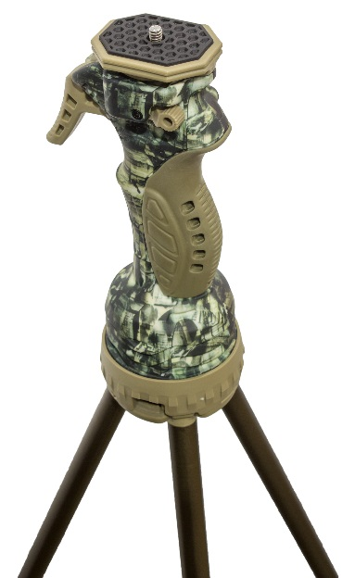
- Replacement V-Yokes
- Easy Detach Camera Mount Accessory

